**TRACING THE GROWTH OF GLOBAL COMMUNITY**

**A POPULATION FORECASTING ANALYSIS**

1. **INTRODUCTION**

A population is defined as a group of individuals of the same species living and interbreeding within a given area. Members of a population often rely on the same resources, are subject to similar environmental constraints, and depend on the availability of other members to persist over time. Scientists study a population by examining how individuals in that population interact with each other and how the population as a whole interacts with its environment. As a tool for **objectively** studying populations, population ecologists rely on a series of statistical measures, known as demographic **parameters**, to describe that population (Lebreton *et al*. 1992). The field of science interested in collecting and analyzing these numbers is termed population demographics, also known as demography.

Broadly defined, demography is the study of the characteristics of populations. It provides a mathematical description of how those characteristics change over time. Demographics can include any statistical factors that influence population growth or decline, but several parameters are particularly important: population size, density, age structure, fecundity (birth rates), mortality (death rates), and sex ratio (Dodge 2006). We introduce each of these in turn.

* 1. OVERVIEW

The world’s population is more than three times larger than it was in the mid-twentieth century. The global human population reached 8.0 billion in mid-November 2022 from an estimated 2.5 billion people in 1950, adding 1 billion people since 2010 and 2 billion since 1998. The world’s population is expected to increase by nearly 2 billion persons in the next 30 years, from the current 8 billion to 9.7 billion in 2050 and could peak at nearly 10.4 billion in the mid-2080s. This dramatic growth has been driven largely by increasing numbers of people surviving to reproductive age, the gradual increase in human lifespan, increasing urbanization, and accelerating migration. Major changes in fertility rate have accompanied this growth. These trends will have far-reaching implications for generations to come.

* 1. PURPOSE

Population analysis is needed to identify problems and community needs, establish goals and objectives, assess alternative courses of action, allocate resources for plan implementation, and evaluate the ability of the plan to achieve goals and objectives.

**2.Proplem definition & design thinking**

2.1 Empathy Map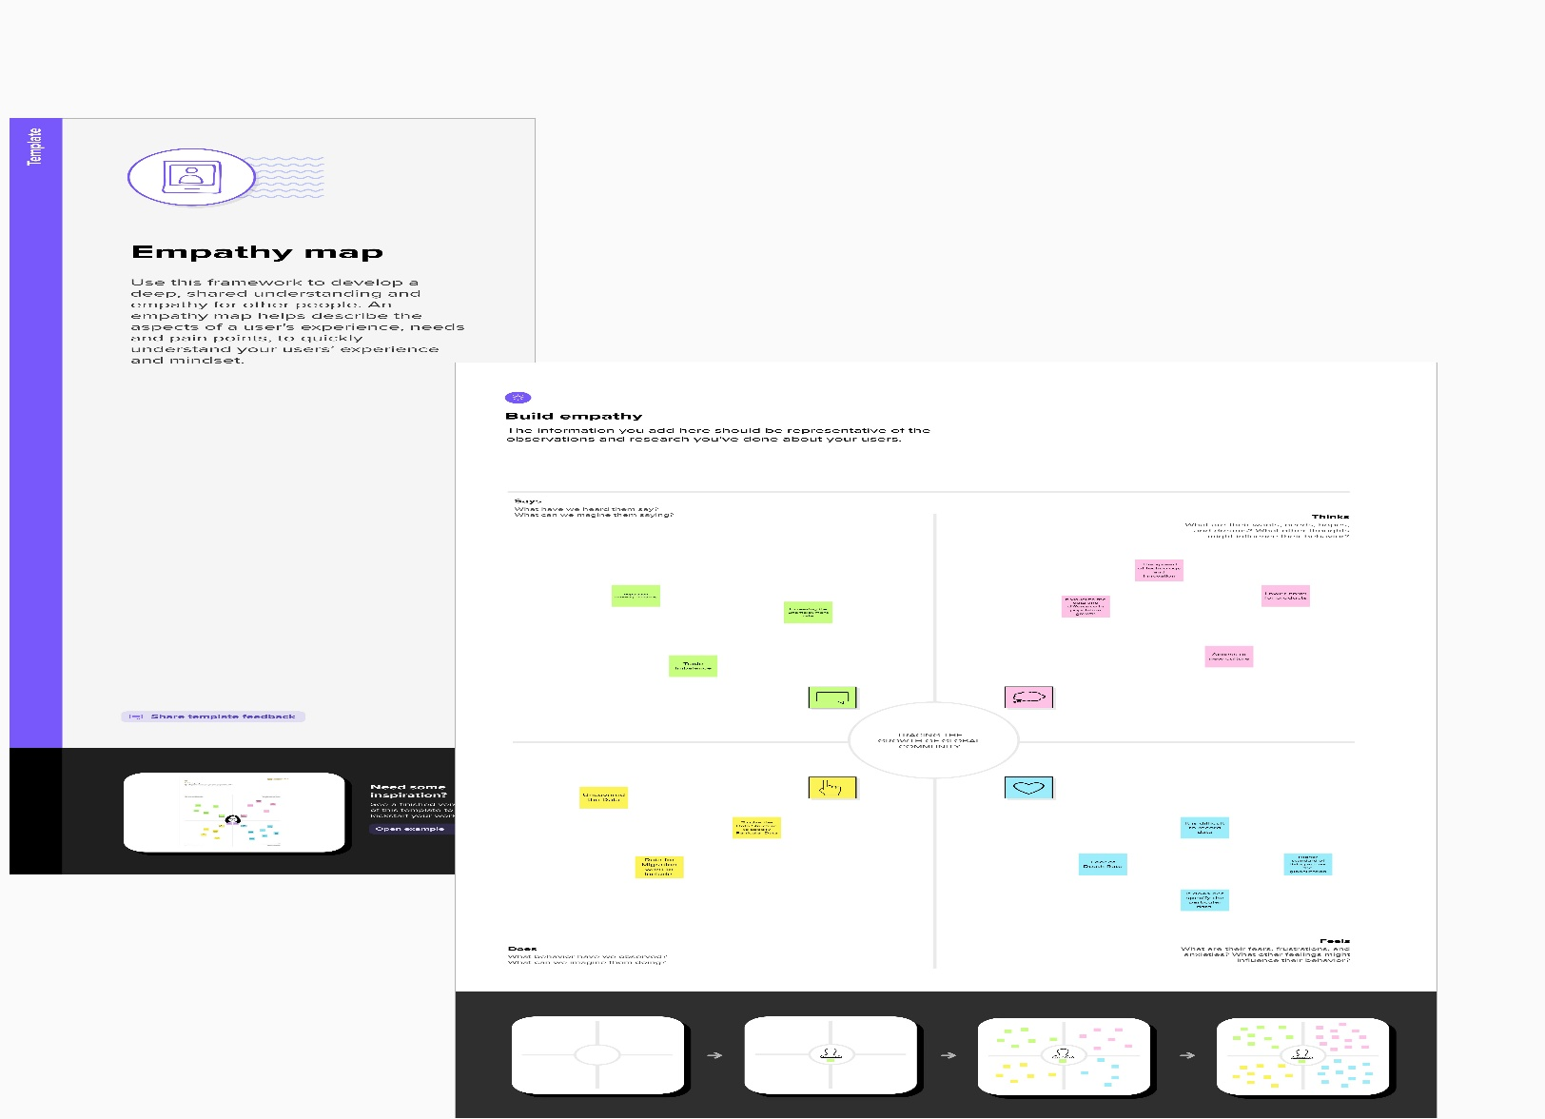

2.2 Ideation & Brainstorming Map

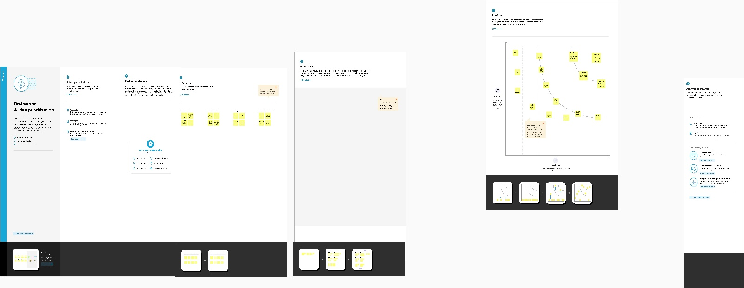

**3.RESULT**

**3.1-Data Collection & Extraction from Database**

Data collection is the process of gathering and measuring information on variables of interest, in an established systematic fashion that enables one to answer stated research questions, test hypotheses, and evaluate outcomes and generate insights from the data.

AREA-.a part of a town, a country or the world.

CITY-a large and important town.

CITY TYPE-rural,semi-urban,urban,metropolitan

COUNTRY OR AREA-A country is a distinct part of the world

RECORD TYPE- a data type that you use to treat several different pieces of data as one unit

RELIABILITY-the degree to which the result of a measurement, calculation, or specification on to be accurate

SEX-determination of gender

YEAR-describes the duration of changes in population

POPULATION-the number of people who live in a particular area, city or country

**3.2-Data Visualization**

Data visualization is the process of creating graphical representations of data in order to help people understand and explore the information. The goal of data visualization is to make complex data sets more accessible, intuitive, and easier to interpret. By using visual elements such as charts, graphs, and maps, data visualizations can help people quickly identify patterns, trends, and outliers in the data.

**3.2.1 population records by type of countries**

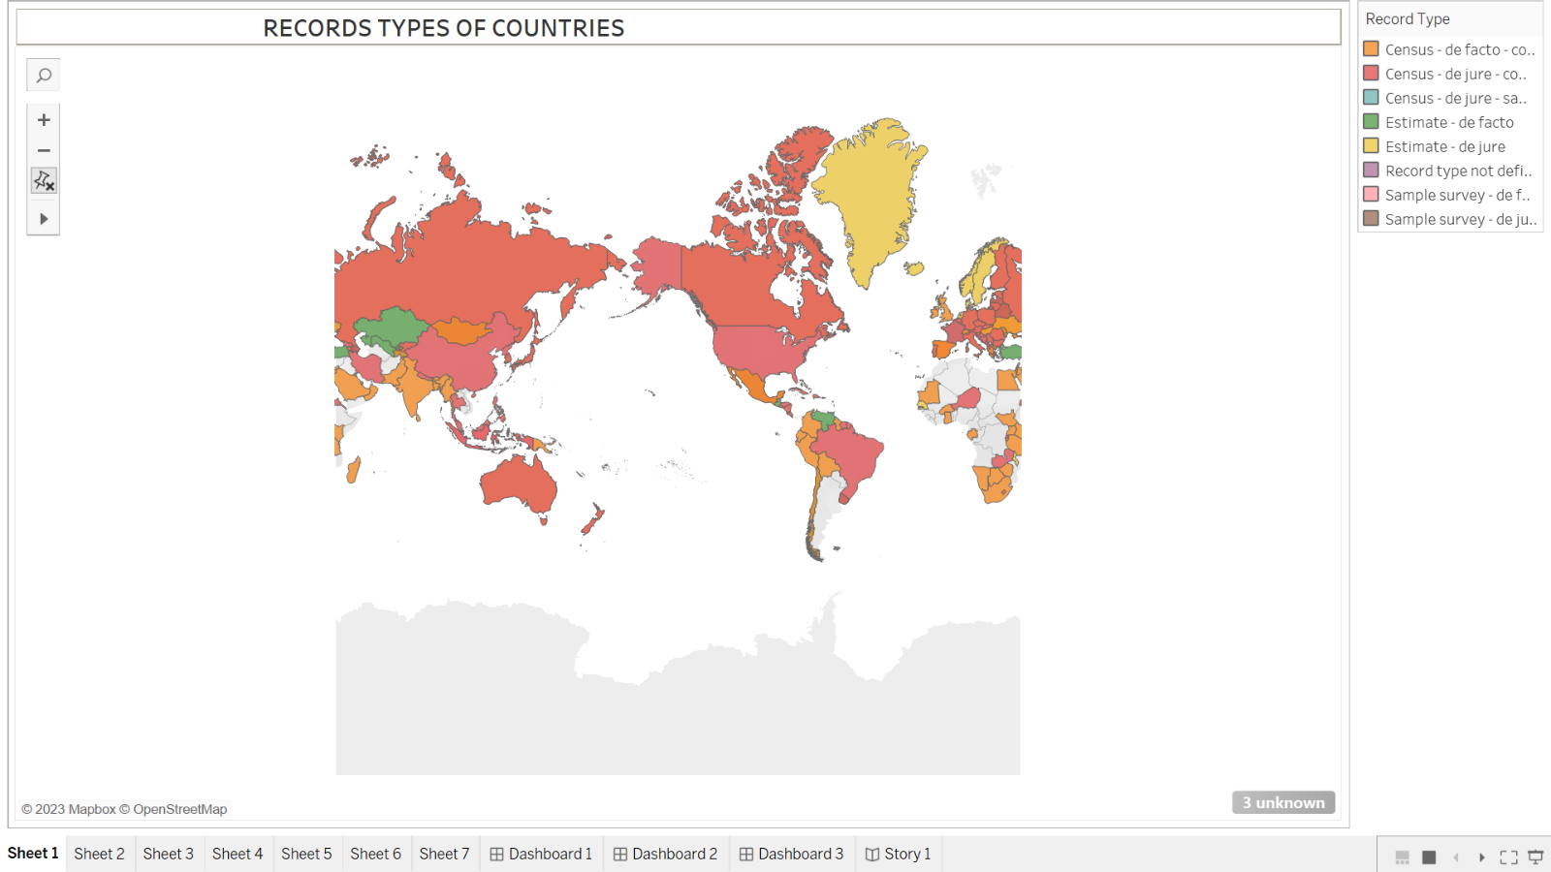

**3.2.2: Population trends over the years**

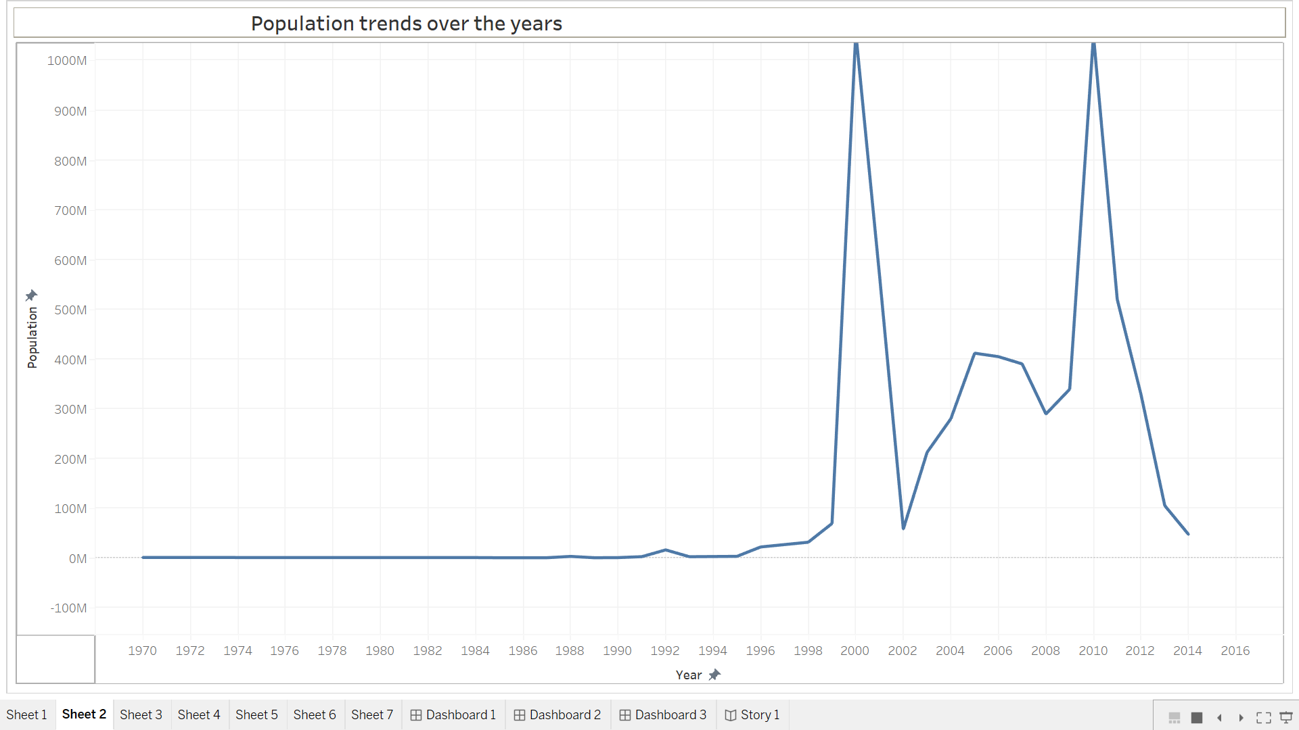

**3.2.3: Population trends over the years by sex**

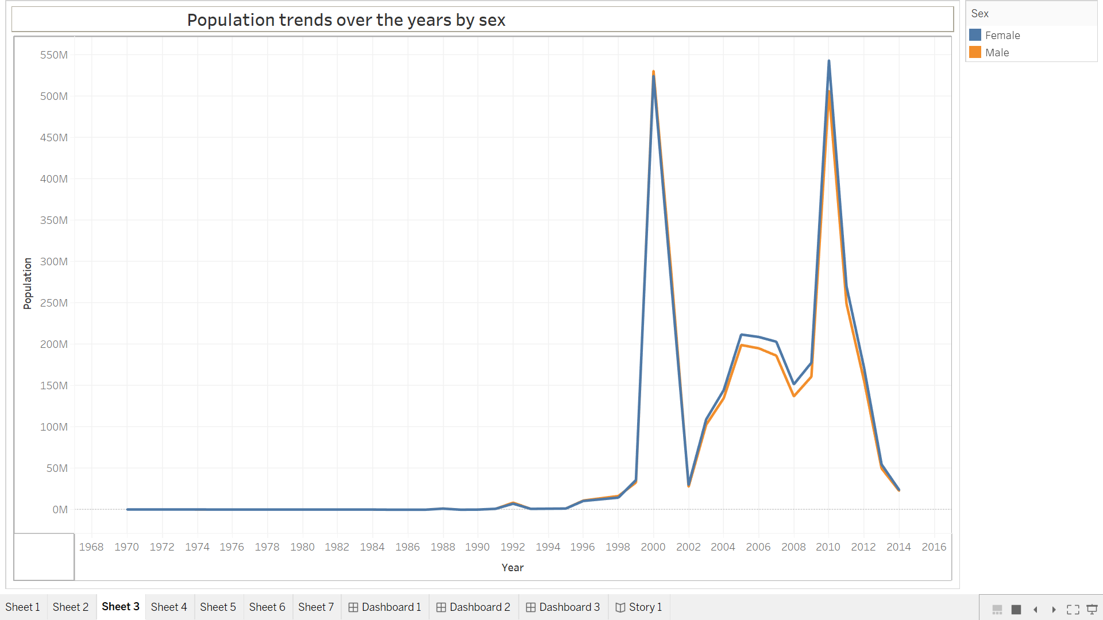

**3.2.4: Cities with highest average populations**

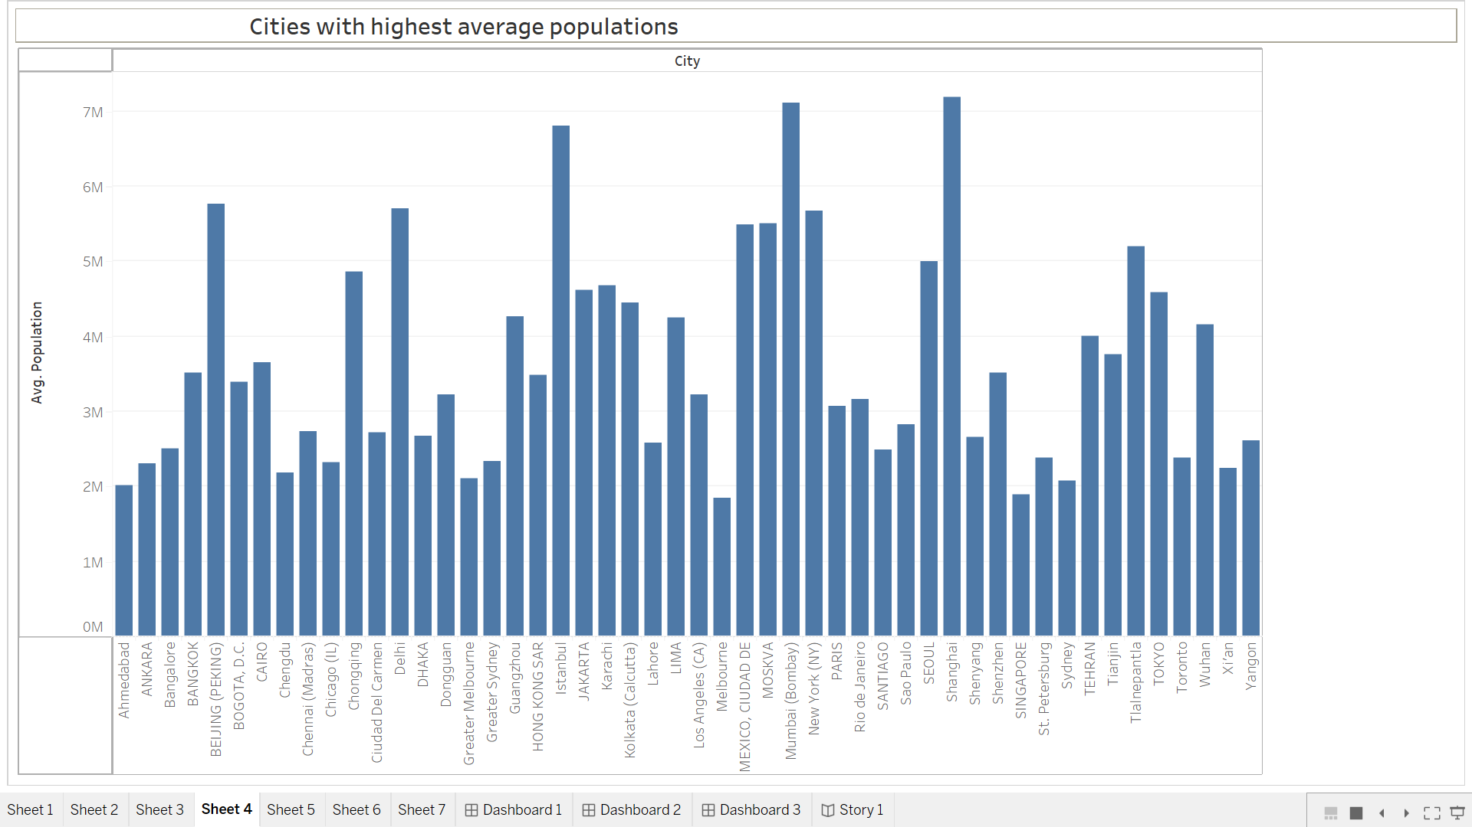

**3.2.5: Countries with highest average population from 2000-2014**

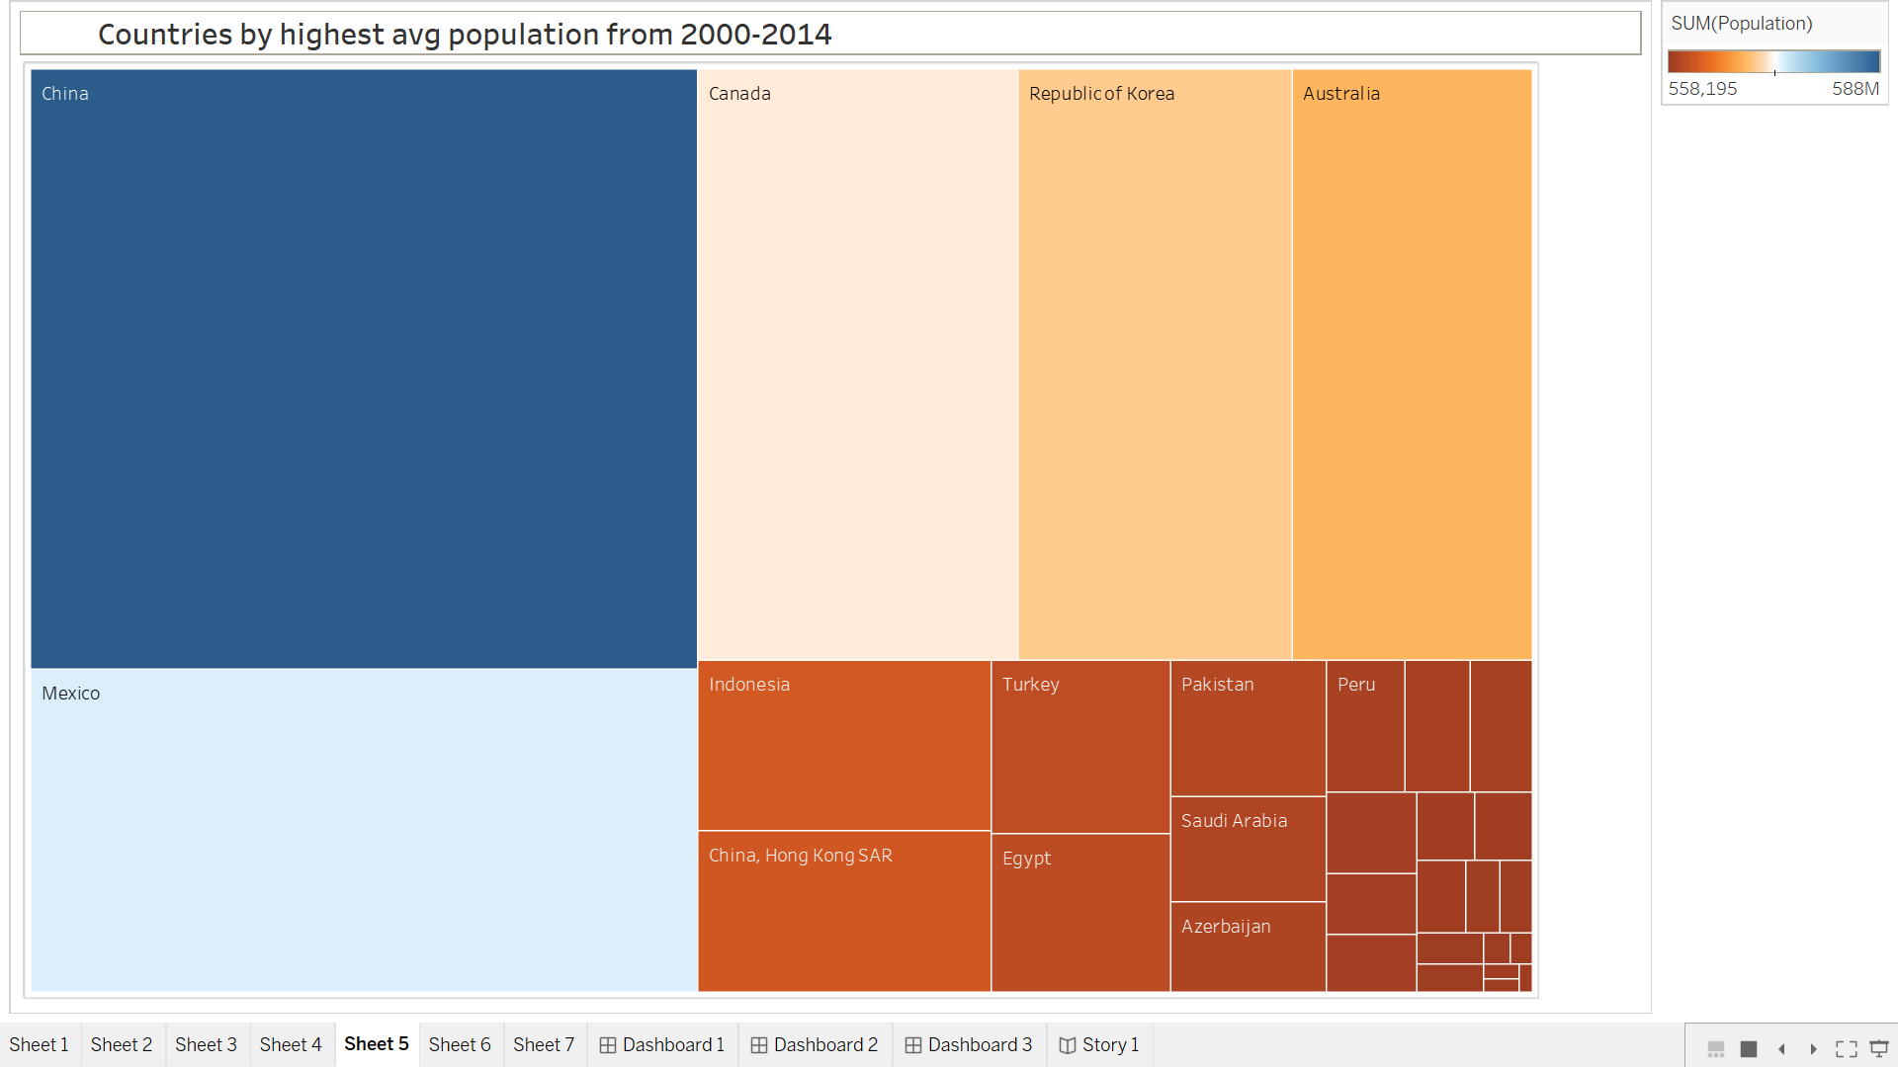

**3.2.6: Population by city type**

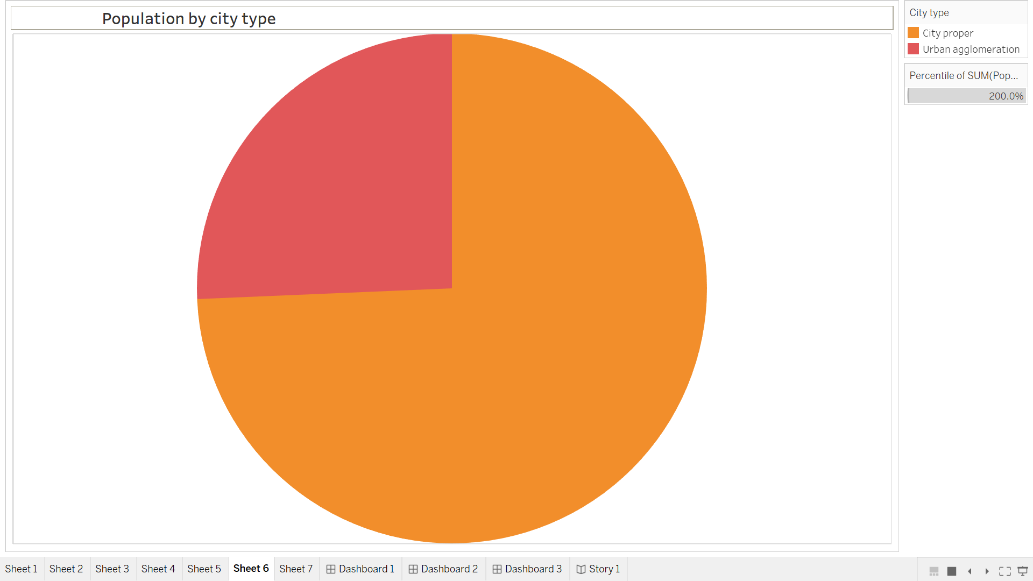

**3.2.7:** : **Population of citied by year**

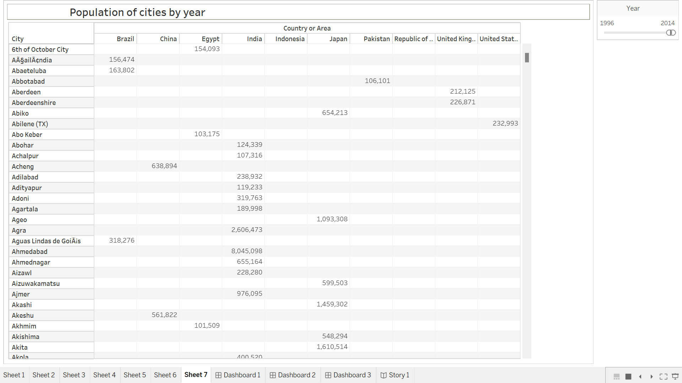

**3.3.3-Dashboard**

A dashboard is a graphical user interface (GUI) that displays information and data in an organized, easy-to-read format. Dashboards are often used to provide real-time monitoring and analysis of data, and are typically designed for a specific purpose or use case. Dashboards can be used in a variety of settings, such as business, finance, manufacturing, healthcare, and many other industries. They can be used to track key performance indicators (KPIs), monitor performance metrics, and display data in the form of charts, graphs, and tables

**POPULATION ANALYSIS DASHBOARD**

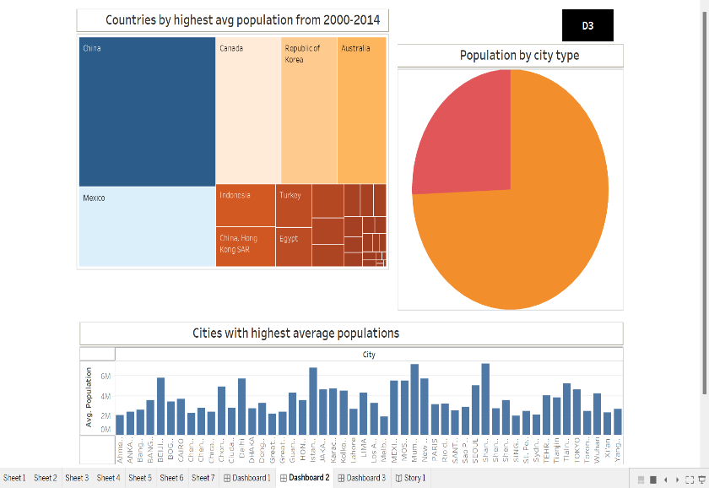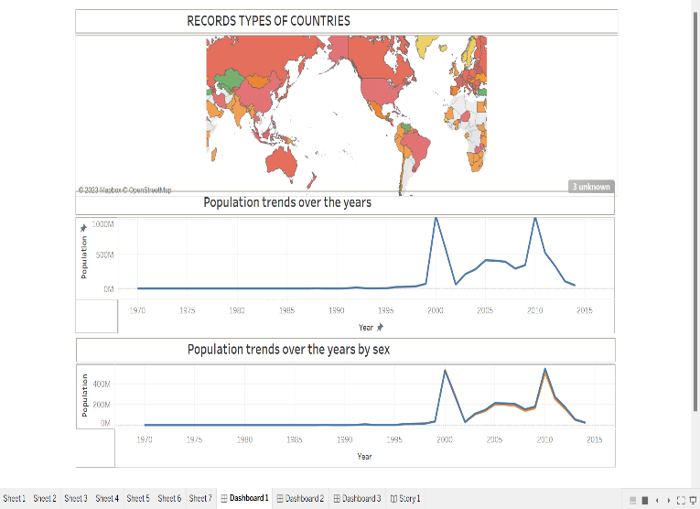 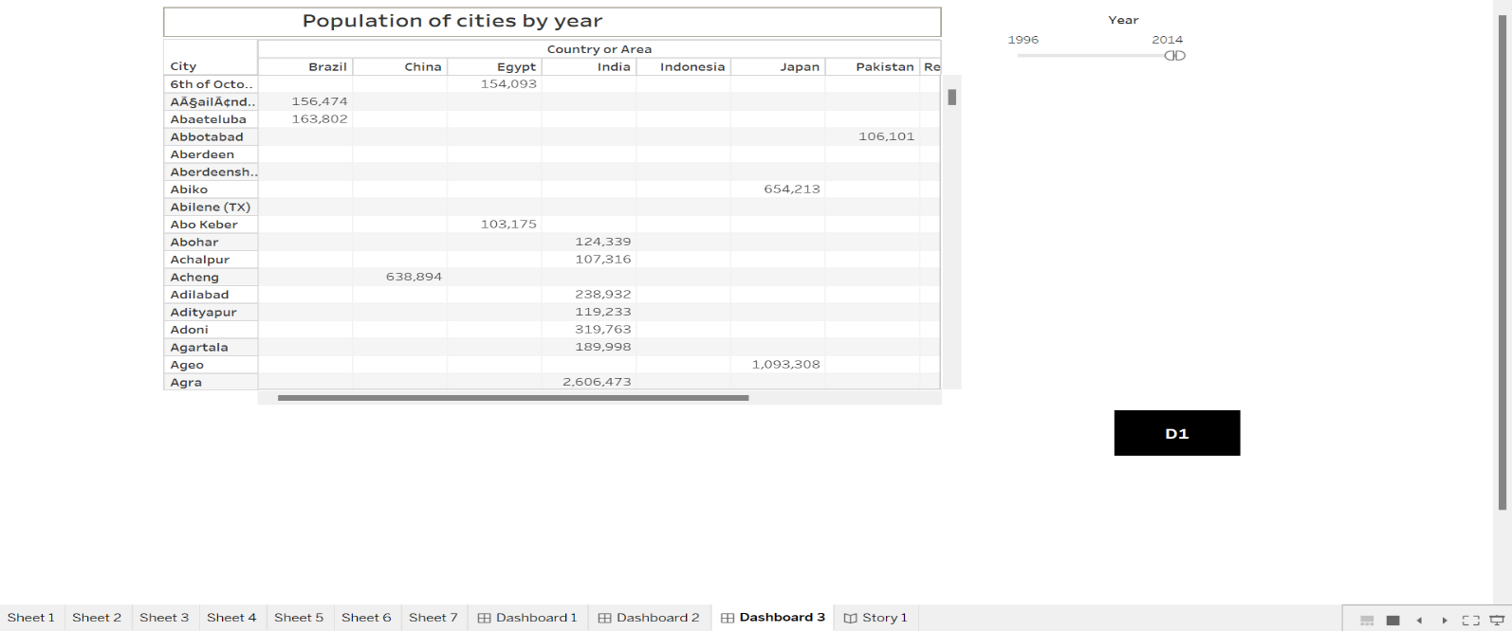

3.4-STORY

A data story is a way of presenting data and analysis in a narrative format, with the goal of making the information more engaging and easier to understand. A data story typically includes a clear introduction that sets the stage and explains the context for the data, a body that presents the data and analysis in a logical and systematic way, and a conclusion that summarizes the key findings and highlights their implications. Data stories can be told using a variety of mediums, such as reports, presentations, interactive visualizations, and videos.

**POPULATION ANALYSIS STORY**

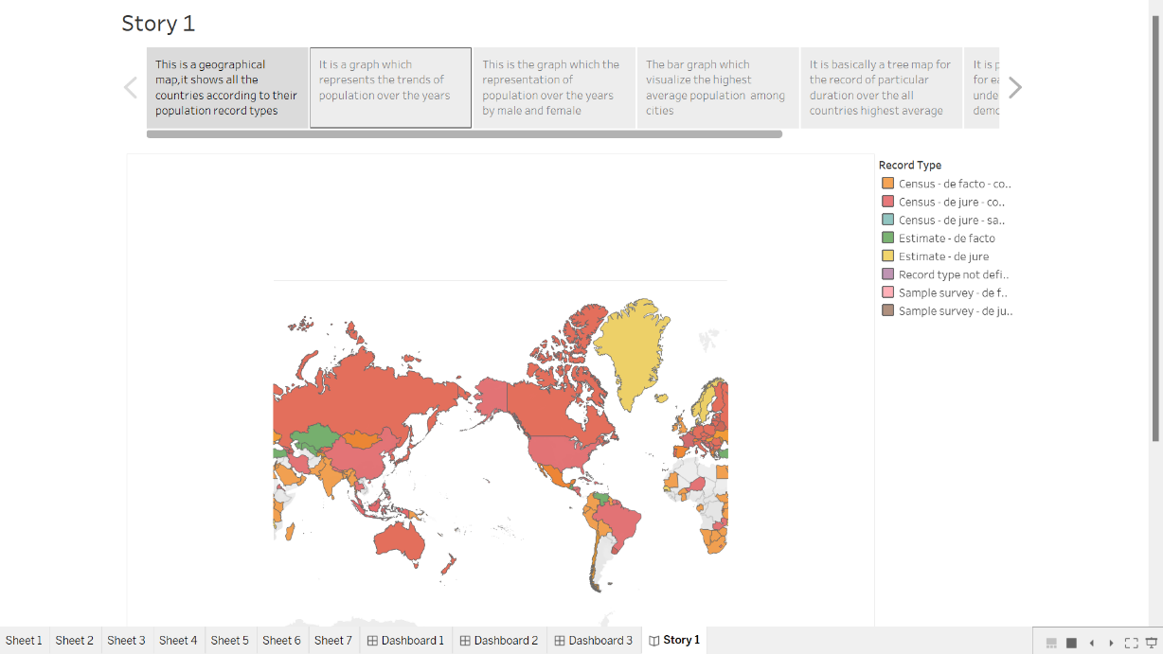

**3.5-Web Integration**

Web data integration (WDI) is the process of aggregating and managing data from different websites into a single, homogeneous workflow. This process includes data access, transformation, mapping, quality assurance and fusion of data. Data that is sourced and structured from websites is referred to as "web data".

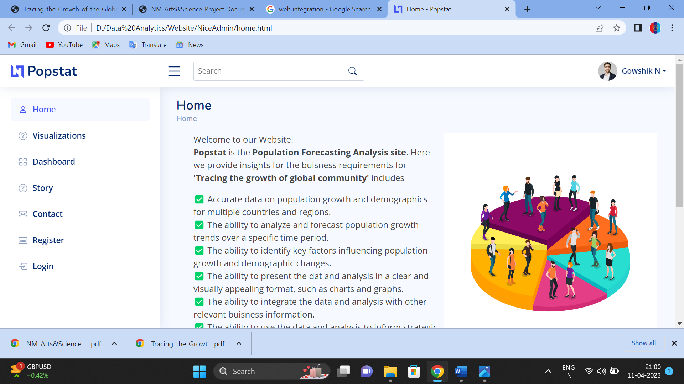

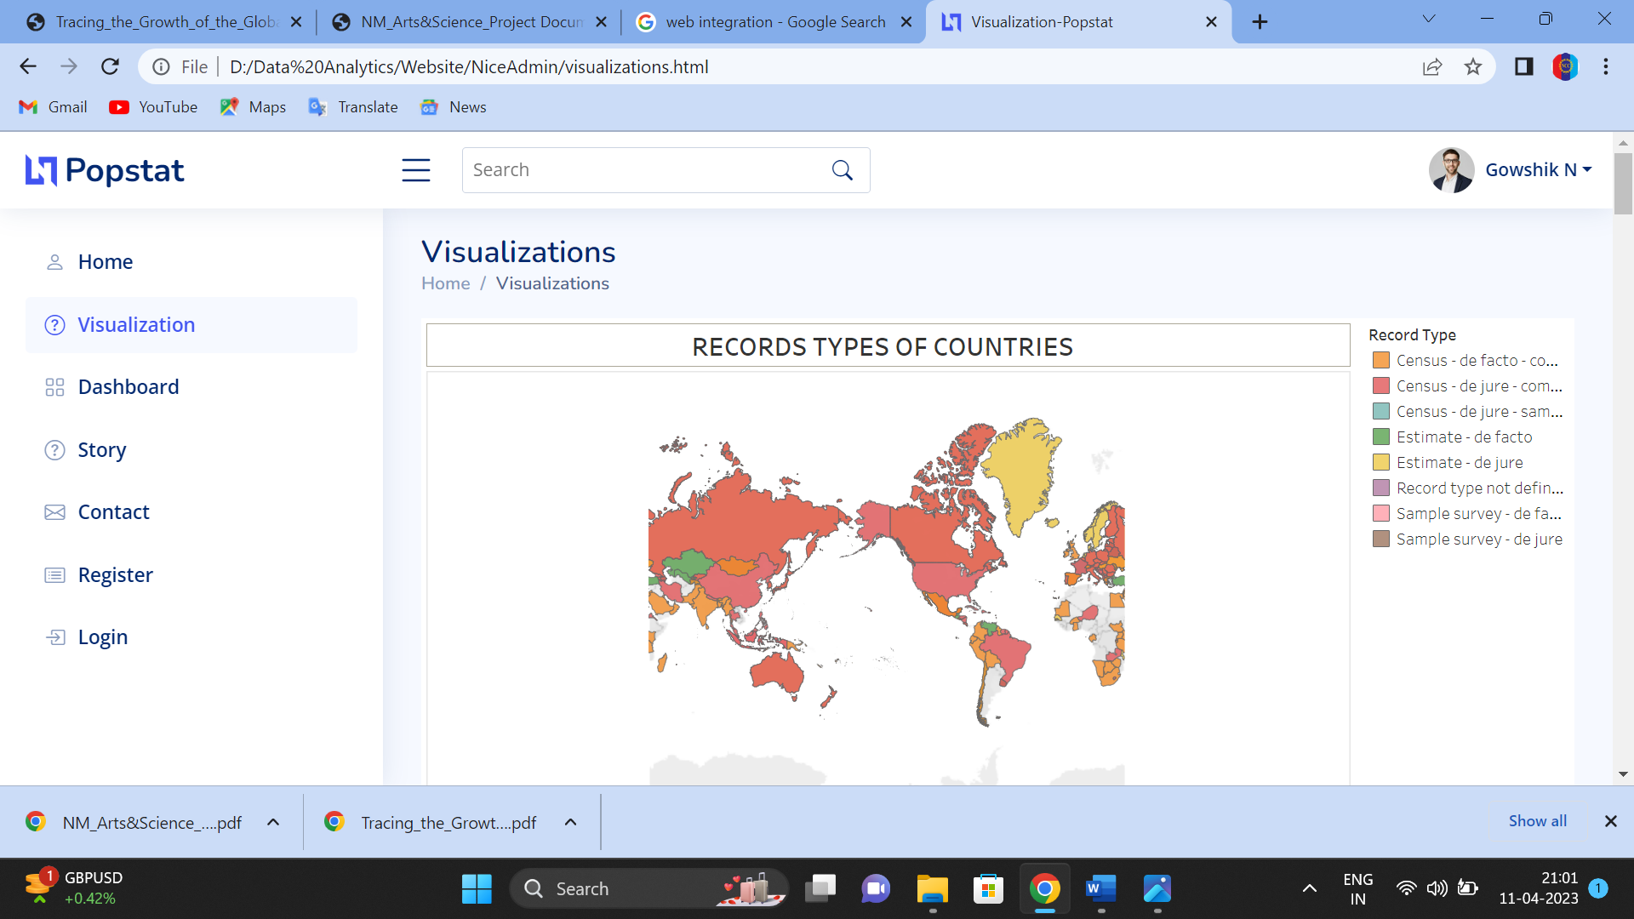

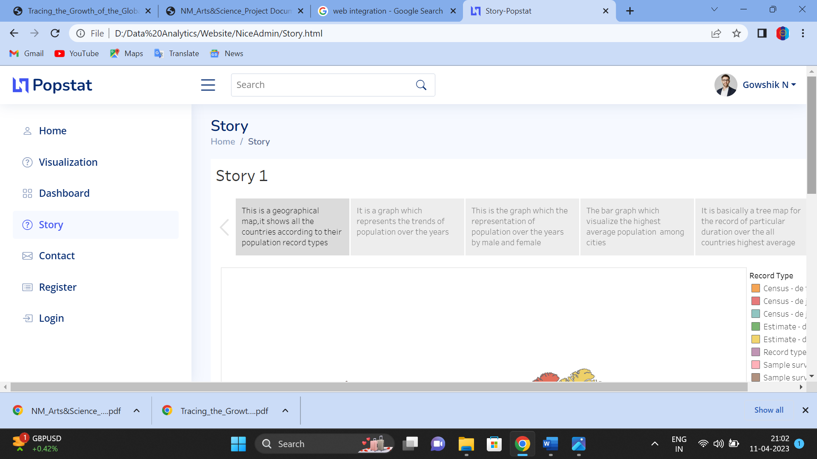 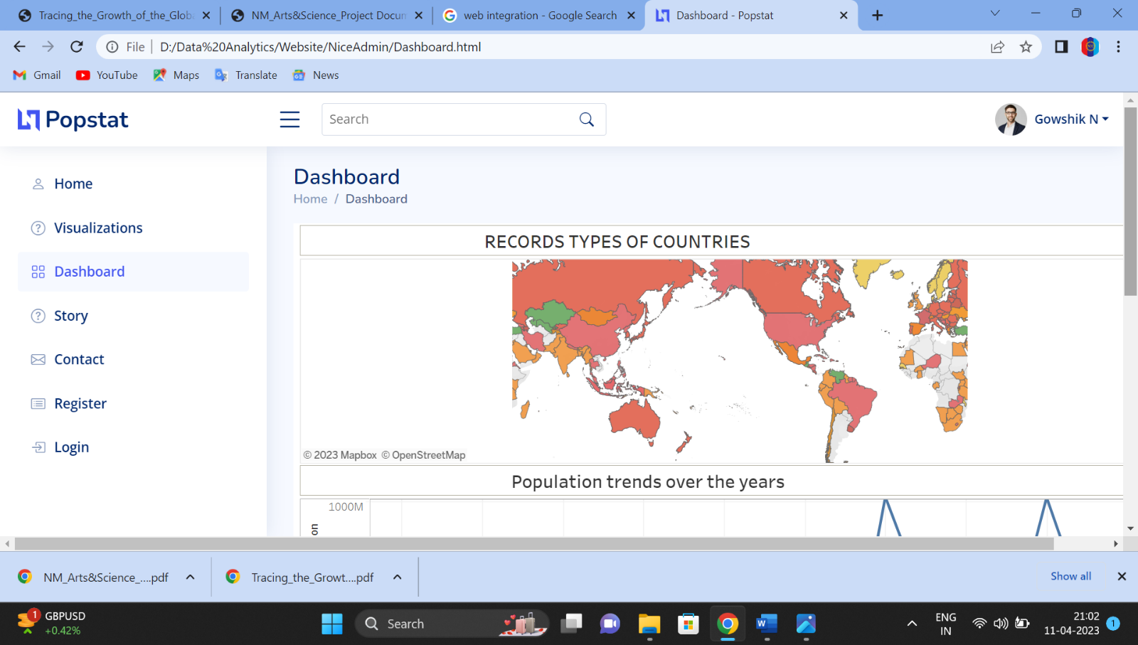

Advantages of Population

* **Greater economic growth**

Population growth will lead to economic expansion since more people can produce more goods. More money will be available in tax revenue to fund public services like environmental and health care programs. The obvious conclusion is that GDP per capita is the essential element rather than GDP as a whole.

* **Human Resources will Increase.**

One obvious advantage that a large population might offer is a larger supply of human resources. In locations where unemployment is a serious problem, this will likely not lead to more jobs, but it will boost the number of individuals willing to work for less pay.

* **Increased productivity through specialization**

The demand for products and services will rise as the population grows, encouraging specialization. This indicates that some people concentrate on creating a single product or service. However, each person's efforts may merge into something amazing depending on their distinct abilities and talents.

Additionally, specialization enables countries to export and participate in globalization. Producers can export commodities to areas afflicted by natural catastrophes or artificial risks instead of only producing locally.

* **Demand has led to more jobs.**

More people means a greater demand for products and services, so more jobs are needed for production. Workers are needed at every level, from the production of basic materials through multiple stages to final distribution during consumption.

More employees are necessary throughout this procedure; thus, they can be needed today even if they weren't previously required for certain talents. Several countries are investing in regulating declining birth rates to address the impending labor deficit.

* **Rapid population decreases Social Infrastructure**

The government must spend a lot of money on necessities like housing, healthcare, and education. However, a rapidly growing population makes the load heavier.

* **Higher population density efficiency**

High population density locations are much more efficient than rural areas and regions with low populations in terms of the per capita carbon footprint. People are more likely to use public transportation and live in easier-to-heat apartment complexes when they reside in densely populated locations.

* **Diversity fosters creativity**

Studies that examined the benefits of immigration as a crucial source of innovation have demonstrated increased diversity. Adding new cultures to the mix enables people from all backgrounds to approach problems creatively.

* **Improved societal demographic structure**

The population is declining in many western economies, which has led to a skewing of the population toward the elderly and retired. We are struggling to pay for health care & pensions, which is placing costs on society. Moderate population increase contributes to rebalancing the population by increasing the proportion of young, working adults.

### Disadvantages of population growth

**1. Cost to the environment.** Population growth exacerbates many of the existing environmental problems

* Trying to reduce carbon and methane emissions to reduce global warming is relatively more difficult as the population.
* There will be greater threat on natural habitats as a greater population has greater demand for housing and farmland. This will increase pressure to cut down forests to make way for farming and housing.
* Higher population will lead to a greater consumption of non-renewable resources, leading to a faster depletion of natural resources.
* Higher population will lead to greater pollution levels in air, water and land. Higher pollution is associated with a range of health issues, such as cancer and asthma. The pollution also harms animals and plants.
* Soil degradation. To feed a growing planet, we have seen serious degrading of farmland (according to UN estimates) about 12 million hectares of farmland every year. This is due to factors, such as overgrazing, use of chemicals, climate change and use of chemicals.

**2. Congestion**.

Too many people in a small space will lead to various types of congestion. Road congestion is a major problem across the world. One study suggested [congestion](https://igees.gov.ie/wp-content/uploads/2018/07/Cost-of-Congestion-Appendix-A-International-Evidence.pdf) cost the EU €111bn (1% of GDP) in 2012. WIth population growth, the costs of congestion will only increase leading to time lost, more pollution and lost output.

**3. Water shortages**.

Already up to 40% of the world’s population face water scarcity and the risk of drought. According to  the [UN](https://www.unccd.int/actions/drought-initiative) water shortages could lead to 700 million people at the risk of displacement. A growing population will put pressure on scarce water supplies and this is a factor behind many minor and major conflicts with countries having to find ways around the shortage of water.

**4. Generating unsustainable waste**.

We are currently generating non-biodegradable rubbish that we are struggling to process. It tends to end in landfill, causing methane emissions and other toxic problems.

**5**.With population growing at an annual average rate of 2.2 per cent, the per capita net availability of certain essential articles of consumption has been very low. The per capita net availability was 33.2 gms of pulses and 159.7 gms of food grains per day.; edible oil 7.5 kg., vanaspati 1.0 kg., sugar 14.5 kg. and cloth 30.9 metres per year in 1998.

Even though the supply of some of these articles is being maintained through domestic production and imports, yet their per capita availability has been low due to the rapid growth of population.



Application of population analysis

A population is a subgroup of individuals within the same species that are living and breeding within a geographic area. The number of individuals living within that specific location determines the population density, or the number of individuals divided by the size of the area.  
  
Population density can be used to describe the location, growth, and migration of many organisms. In the case of humans, population density is often discussed in relation to urbanization, immigration, and population demographics.  
  
Globally, statistics related to population density are tracked by the United Nations Statistics Division, and the United States Constitution requires population data to be collected every 10 years, an operation carried out by the U.S. Census Bureau. However, data on human population density at the country level, and even at regional levels, may not be very informative; society tends to form clusters that can be surrounded by sparsely inhabited areas. Therefore, the most useful data describes smaller, more discrete population centers.  
  
Dense population clusters generally coincide with geographical locations often referred to as city, or as an urban or metropolitan area; sparsely populated areas are often referred to as rural. These terms do not have globally agreed upon definitions, but they are useful in general discussions about population density and geographic location.  
  
Population density data can be important for many related studies, including studies of ecosystems and improvements to human health and infrastructure. For example, the World Health Organization, the U.S. Energy Information Administration, the U.S. Global Change Research Program, and the U.S. Departments of Energy and Agriculture all use population data from the U.S. Census or UN statistics to understand and better predict resource use and health trends.  
  
Key areas of study include the following:

* Ecology: how increasing population density in certain areas impacts biodiversity and use of natural resources.
* Epidemiology: how densely populated areas differ with respect to incidence, prevalence, and transmission of infectious disease.
* Infrastructure: how population density drives specific requirements for energy use and the transport of goods.

This list is not inclusive—the way society structures its living spaces affects many other fields of study as well. Scientists have even studied how happiness correlates with population density. A substantial area of study, however, focuses on demographics of populations as they relate to density. Areas of demographic breakdown and study include, but are not limited to:

* age (including tracking of elderly population centers);
* sex (biological classification as male or female); and
* race and ethnic group, or cultural characteristics

**6.CONCLUSION**

Overpopulation may cause a variety of problems, including natural resource depletion, environmental pollution and degradation, and loss of the natural environment. To control and manage the growing human population, all nations must act quickly.

**7.FUTURE SCOPE 0F POPULATION ANALYSIS**

The current world population of 7.6 billion is expected to reach 8.6 billion in 2030, 9.8 billion in 2050 and 11.2 billion in 2100, according to a new United Nations report being launched today. With roughly 83 million people being added to the world’s population every year, the upward trend in population size is expected to continue, even assuming that fertility levels will continue to decline.  
  
The World Population Prospects: The 2017 Revision, published by the UN Department of Economic and Social Affairs, provides a comprehensive review of global demographic trends and prospects for the future. The information is essential to guide policies aimed at achieving the new Sustainable Development Goals.  
  
**Shifts in country population rankings**  
  
The new projections include some notable findings at the country level. China (with 1.4 billion inhabitants) and India (1.3 billion inhabitants) remain the two most populous countries, comprising 19 and 18% of the total global population. In roughly seven years, or around 2024, the population of India is expected to surpass that of China.  
  
Among the ten largest countries worldwide, Nigeria is growing the most rapidly. Consequently, the population of Nigeria, currently the world’s 7th largest, is projected to surpass that of the United States and become the third largest country in the world shortly before 2050.  
  
**Most of the global increase is attributable to a small number of countries**  
  
From 2017 to 2050, it is expected that half of the world’s population growth will be concentrated in just nine countries: India, Nigeria, the Democratic Republic of the Congo, Pakistan, Ethiopia, the United Republic of Tanzania, the United States of America, Uganda and Indonesia (ordered by their expected contribution to total growth).  
  
The group of 47 least developed countries (LDCs) continues to have a relatively high level of fertility, which stood at 4.3 births per woman in 2010-2015. As a result, the population of these countries has been growing rapidly, at around 2.4 % per year. Although this rate of increase is expected to slow significantly over the coming decades, the combined population of the LDCs, roughly one billion in 2017, is projected to increase by 33 % between 2017 and 2030, and to reach 1.9 billion persons in 2050.  
  
Similarly, Africa continues to experience high rates of population growth. Between 2017 and 2050, the populations of 26 African countries are projected to expand to at least double their current size.  
  
The concentration of global population growth in the poorest countries presents a considerable challenge to governments in implementing the 2030 Agenda for Sustainable Development, which seeks to end poverty and hunger, expand and update health and education systems, achieve gender equality and women’s empowerment, reduce inequality and ensure that no one is left behind.  
  
**Slower world population growth due to lower fertility rates**  
  
In recent years, fertility has declined in nearly all regions of the world. Even in Africa, where fertility levels are the highest of any region, total fertility has fallen from 5.1 births per woman in 2000-2005 to 4.7 in 2010-2015.  
  
Europe has been an exception to this trend in recent years, with total fertility increasing from 1.4 births per woman in 2000-2005 to 1.6 in 2010-2015.  
  
More and more countries now have fertility rates below the level required for the replacement of successive generations (roughly 2.1 births per woman), and some have been in this situation for several decades. During 2010-2015, fertility was below the replacement level in 83 countries comprising 46 % of the world’s population. The ten most populous countries in this group are China, the United States of America, Brazil, the Russian Federation, Japan, Viet Nam, Germany, the Islamic Republic of Iran, Thailand, and the United Kingdom (in order of population size).  
  
**Lower fertility leads also to ageing populations**  
  
The report highlights that a reduction in the fertility level results not only in a slower pace of population growth but also in an older population.  
  
Compared to 2017, the number of persons aged 60 or above is expected to more than double by 2050 and to more than triple by 2100, rising from 962 million globally in 2017 to 2.1 billion in 2050 and 3.1 billion in 2100.  
  
In Europe, 25% of the population is already aged 60 years or over. That proportion is projected to reach 35% in 2050 and to remain around that level in the second half of the century. Populations in other regions are also projected to age significantly over the next several decades and continuing through 2100. Africa, for example, which has the youngest age distribution of any region, is projected to experience a rapid ageing of its population. Although the African population will remain relatively young for several more decades, the percentage of its population aged 60 or over is expected to rise from 5% in 2017 to around 9% in 2050, and then to nearly 20% by the end of the century.  
  
Globally, the number of persons aged 80 or over is projected to triple by 2050, from 137 million in 2017 to 425 million in 2050. By 2100 it is expected to increase to 909 million, nearly seven times its value in 2017.  
  
Population ageing is projected to have a profound effect on societies, underscoring the fiscal and political pressures that the health care, old-age pension and social protection systems of many countries are likely to face in the coming decades.  
  
**Higher life expectancy worldwide**  
  
Substantial improvements in life expectancy have occurred in recent years. Globally, life expectancy at birth has risen from 65 years for men and 69 years for women in 2000-2005 to 69 years for men and 73 years for women in 2010-2015. Nevertheless, large disparities across countries remain.  
  
Although all regions shared in the recent rise of life expectancy, the greatest gains were for Africa, where life expectancy rose by 6.6 years between 2000-2005 and 2010-2015 after rising by less than 2 years over the previous decade.  
  
The gap in life expectancy at birth between the least developed countries and other developing countries narrowed from 11 years in 2000-2005 to 8 years in 2010-2015. Although differences in life expectancy across regions and income groups are projected to persist in future years, such differences are expected to diminish significantly by 2045-2050.  
  
The increased level and reduced variability in life expectancy have been due to many factors, including a lower under-five mortality rate, which fell by more than 30 % in 89 countries between 2000-2005 and 2010-2015. Other factors include continuing reductions in fatalities due to HIV/AIDS and progress in combating other infectious as well as non-communicable diseases.  
  
**Large movements of refugees and other migrants**  
  
There continue to be large movements of migrants between regions, often from low- and middle-income countries toward high-income countries. The volume of the net inflow of migrants to high-income countries in 2010-2015 (3.2 million per year) represented a decline from a peak attained in 2005-2010 (4.5 million per year). Although international migration at or around current levels will be insufficient to compensate fully for the expected loss of population tied to low levels of fertility, especially in the European region, the movement of people between countries can help attenuate some of the adverse consequences of population ageing.  
  
The report observes that the Syrian refugee crisis has had a major impact on levels and patterns of international migration in recent years, affecting several countries. The estimated net outflow from the Syrian Arab Republic was 4.2 million persons in 2010-2015. Most of these refugees went to Syria’s neighbouring countries, contributing to a substantial increase in the net inflow of migrants especially to Turkey, Lebanon and Jordan.  
  
**About the report**  
  
The 2017 Revision of World Population Prospects is the 25th round of official UN population estimates and projections that have been prepared by the Population Division of the United Nations Department of Economic and Social Affairs.  
  
The 2017 Revision builds on previous revisions by incorporating additional results from the 2010 and 2020 rounds of national population censuses as well as findings from recent specialized sample surveys from around the world. The 2017 Revision provides a comprehensive set of demographic data and indicators that can be used to assess population trends at the global, regional and national levels and to calculate other key indicators for monitoring progress toward the Sustainable Development Goals.

**8.APPENDIX**

**SOURCE CODE FOR HTML**

**SOURCE FOR HOME**

**<!DOCTYPE html>**

**<html lang="en">**

**<head>**

**<meta charset="utf-8">**

**<meta content="width=device-width, initial-scale=1.0" name="viewport">**

**<title>Profile - Popstat</title>**

**<meta content="" name="description">**

**<meta content="" name="keywords">**

**<!-- Favicons -->**

**<link href="assets/img/favicon.png" rel="icon">**

**<link href="assets/img/apple-touch-icon.png" rel="apple-touch-icon">**

**<!-- Google Fonts -->**

**<link href="https://fonts.gstatic.com" rel="preconnect">**

**<link href="https://fonts.googleapis.com/css?family=Open+Sans:300,300i,400,400i,600,600i,700,700i|Nunito:300,300i,400,400i,600,600i,700,700i|Poppins:300,300i,400,400i,500,500i,600,600i,700,700i" rel="stylesheet">**

**<!-- Vendor CSS Files -->**

**<link href="assets/vendor/bootstrap/css/bootstrap.min.css" rel="stylesheet">**

**<link href="assets/vendor/bootstrap-icons/bootstrap-icons.css" rel="stylesheet">**

**<link href="assets/vendor/boxicons/css/boxicons.min.css" rel="stylesheet">**

**<link href="assets/vendor/quill/quill.snow.css" rel="stylesheet">**

**<link href="assets/vendor/quill/quill.bubble.css" rel="stylesheet">**

**<link href="assets/vendor/remixicon/remixicon.css" rel="stylesheet">**

**<link href="assets/vendor/simple-datatables/style.css" rel="stylesheet">**

**<!-- Template Main CSS File -->**

**<link href="assets/css/style.css" rel="stylesheet">**

**<!-- =======================================================**

**\* Template Name: NiceAdmin**

**\* Updated: Mar 09 2023 with Bootstrap v5.2.3**

**\* Template URL: https://bootstrapmade.com/nice-admin-bootstrap-admin-html-template/**

**\* Author: BootstrapMade.com**

**\* License: https://bootstrapmade.com/license/**

**======================================================== -->**

**</head>**

**<body>**

**<!-- ======= Header ======= -->**

**<header id="header" class="header fixed-top d-flex align-items-center">**

**<div class="d-flex align-items-center justify-content-between">**

**<a href="index.html" class="logo d-flex align-items-center">**

**<img src="assets/img/logo.png" alt="">**

**<span class="d-none d-lg-block">Popstat</span>**

**</a>**

**<i class="bi bi-list toggle-sidebar-btn"></i>**

**</div><!-- End Logo -->**

**<div class="search-bar">**

**<form class="search-form d-flex align-items-center" method="POST" action="#">**

**<input type="text" name="query" placeholder="Search" title="Enter search keyword">**

**<button type="submit" title="Search"><i class="bi bi-search"></i></button>**

**</form>**

**</div><!-- End Search Bar -->**

**<nav class="header-nav ms-auto">**

**<ul class="d-flex align-items-center">**

**<li class="nav-item d-block d-lg-none">**

**<a class="nav-link nav-icon search-bar-toggle " href="#">**

**<i class="bi bi-search"></i>**

**</a>**

**</li><!-- End Search Icon-->**

**<li class="nav-item dropdown pe-3">**

**<a class="nav-link nav-profile d-flex align-items-center pe-0" href="#" data-bs-toggle="dropdown">**

**<img src="assets/img/profile-img.jpg" alt="Profile" class="rounded-circle">**

**<span class="d-none d-md-block dropdown-toggle ps-2">Gowshik N</span>**

**</a><!-- End Profile Iamge Icon -->**

**<ul class="dropdown-menu dropdown-menu-end dropdown-menu-arrow profile">**

**<li class="dropdown-header">**

**<h6>Gowshik N</h6>**

**<span>D</span>**

**</li>**

**<li>**

**<hr class="dropdown-divider">**

**</li>**

**<li>**

**<a class="dropdown-item d-flex align-items-center" href="users-profile.html">**

**<i class="bi bi-person"></i>**

**<span>My Profile</span>**

**</a>**

**</li>**

**<li>**

**<hr class="dropdown-divider">**

**</li>**

**<li>**

**<a class="dropdown-item d-flex align-items-center" href="users-profile.html">**

**<i class="bi bi-gear"></i>**

**<span>Account Settings</span>**

**</a>**

**</li>**

**<li>**

**<hr class="dropdown-divider">**

**</li>**

**<li>**

**<a class="dropdown-item d-flex align-items-center" href="pages-faq.html">**

**<i class="bi bi-question-circle"></i>**

**<span>Need Help?</span>**

**</a>**

**</li>**

**<li>**

**<hr class="dropdown-divider">**

**</li>**

**<li>**

**<a class="dropdown-item d-flex align-items-center" href="#">**

**<i class="bi bi-box-arrow-right"></i>**

**<span>Sign Out</span>**

**</a>**

**</li>**

**</ul><!-- End Profile Dropdown Items -->**

**</li><!-- End Profile Nav -->**

**</ul>**

**</nav><!-- End Icons Navigation -->**

**</header><!-- End Header -->**

**<!-- ======= Sidebar ======= -->**

**<aside id="sidebar" class="sidebar">**

**<ul class="sidebar-nav" id="sidebar-nav">**

**<li class="nav-item">**

**<a class="nav-link collapsed" href="home.html">**

**<i class="bi bi-person"></i>**

**<span>Home</span>**

**</a>**

**</li><!-- End Home nav -->**

**<li class="nav-item">**

**<a class="nav-link collapsed" href="visualizations.html">**

**<i class="bi bi-question-circle"></i>**

**<span>Visualizations</span>**

**</a>**

**</li><!-- End Visualization -->**

**<li class="nav-item">**

**<a class="nav-link collapsed" href="Dashboard.html">**

**<i class="bi bi-grid"></i>**

**<span>Dashboard</span>**

**</a>**

**</li><!-- End Dashboard Nav -->**

**<li class="nav-item">**

**<a class="nav-link collapsed" href="Story.html">**

**<i class="bi bi-question-circle"></i>**

**<span>Story</span>**

**</a>**

**</li><!-- End Story -->**

**<li class="nav-item">**

**<a class="nav-link collapsed" href="pages-contact.html">**

**<i class="bi bi-envelope"></i>**

**<span>Contact</span>**

**</a>**

**</li><!-- End Contact Nav -->**

**<li class="nav-item">**

**<a class="nav-link collapsed" href="pages-register.html">**

**<i class="bi bi-card-list"></i>**

**<span>Register</span>**

**</a>**

**</li><!-- End Register Page Nav -->**

**<li class="nav-item">**

**<a class="nav-link collapsed" href="pages-login.html">**

**<i class="bi bi-box-arrow-in-right"></i>**

**<span>Login</span>**

**</a>**

**</li><!-- End Login Page Nav -->**

**</ul>**

**</aside><!-- End Sidebar-->**

**<main id="main" class="main">**

**<div class="pagetitle">**

**<h1>Profile</h1>**

**<nav>**

**<ol class="breadcrumb">**

**<li class="breadcrumb-item"><a href="index.html">Home</a></li>**

**<li class="breadcrumb-item">Users</li>**

**<li class="breadcrumb-item active">Profile</li>**

**</ol>**

**</nav>**

**</div><!-- End Page Title -->**

**<section class="section profile">**

**<div class="row">**

**<div class="col-xl-4">**

**<div class="card">**

**<div class="card-body profile-card pt-4 d-flex flex-column align-items-center">**

**<img src="assets/img/profile-img.jpg" alt="Profile" class="rounded-circle">**

**<h2>Gowshik N</h2>**

**<h3>Data Analyst</h3>**

**</div>**

**</div>**

**</div>**

**<div class="col-xl-8">**

**<div class="card">**

**<div class="card-body pt-3">**

**<!-- Bordered Tabs -->**

**<ul class="nav nav-tabs nav-tabs-bordered">**

**<li class="nav-item">**

**<button class="nav-link active" data-bs-toggle="tab" data-bs-target="#profile-overview">Overview</button>**

**</li>**

**<li class="nav-item">**

**<button class="nav-link" data-bs-toggle="tab" data-bs-target="#profile-edit">Edit Profile</button>**

**</li>**

**<li class="nav-item">**

**<button class="nav-link" data-bs-toggle="tab" data-bs-target="#profile-settings">Settings</button>**

**</li>**

**<li class="nav-item">**

**<button class="nav-link" data-bs-toggle="tab" data-bs-target="#profile-change-password">Change Password</button>**

**</li>**

**</ul>**

**<div class="tab-content pt-2">**

**<div class="tab-pane fade show active profile-overview" id="profile-overview">**

**<h5 class="card-title">About</h5>**

**<p class="small fst-italic">a data analyst who analysis the data of population forecasting,and visuales the records of population of the world</p>**

**<h5 class="card-title">Profile Details</h5>**

**<div class="row">**

**<div class="col-lg-3 col-md-4 label ">Full Name</div>**

**<div class="col-lg-9 col-md-8">Gowshik N</div>**

**</div>**

**<div class="row">**

**<div class="col-lg-3 col-md-4 label">Company</div>**

**<div class="col-lg-9 col-md-8">FPBT,TTP,WWP,LLP,RPP,ME,EOE,TE</div>**

**</div>**

**<div class="row">**

**<div class="col-lg-3 col-md-4 label">Job</div>**

**<div class="col-lg-9 col-md-8">Data Analyst</div>**

**</div>**

**<div class="row">**

**<div class="col-lg-3 col-md-4 label">Country</div>**

**<div class="col-lg-9 col-md-8">India</div>**

**</div>**

**<div class="row">**

**<div class="col-lg-3 col-md-4 label">Address</div>**

**<div class="col-lg-9 col-md-8">74B-8,west colony ,komarapalayam,namakkal,TN-638183.</div>**

**</div>**

**<div class="row">**

**<div class="col-lg-3 col-md-4 label">Phone</div>**

**<div class="col-lg-9 col-md-8">91 6383 2016 81</div>**

**</div>**

**<div class="row">**

**<div class="col-lg-3 col-md-4 label">Email</div>**

**<div class="col-lg-9 col-md-8">gowshikbharathi100@gmail.com</div>**

**</div>**

**</div>**

**<div class="tab-pane fade profile-edit pt-3" id="profile-edit">**

**<!-- Profile Edit Form -->**

**<form>**

**<div class="row mb-3">**

**<label for="profileImage" class="col-md-4 col-lg-3 col-form-label">Profile Image</label>**

**<div class="col-md-8 col-lg-9">**

**<img src="assets/img/profile-img.jpg" alt="Profile">**

**<div class="pt-2">**

**<a href="#" class="btn btn-primary btn-sm" title="Upload new profile image"><i class="bi bi-upload"></i></a>**

**<a href="#" class="btn btn-danger btn-sm" title="Remove my profile image"><i class="bi bi-trash"></i></a>**

**</div>**

**</div>**

**</div>**

**<div class="row mb-3">**

**<label for="fullName" class="col-md-4 col-lg-3 col-form-label">Full Name</label>**

**<div class="col-md-8 col-lg-9">**

**<input name="fullName" type="text" class="form-control" id="fullName" value="Gowshik N">**

**</div>**

**</div>**

**<div class="row mb-3">**

**<label for="about" class="col-md-4 col-lg-3 col-form-label">About</label>**

**<div class="col-md-8 col-lg-9">**

**<textarea name="about" class="form-control" id="about" style="height: 100px">Sunt est soluta temporibus accusantium neque nam maiores cumque temporibus. Tempora libero non est unde veniam est qui dolor. Ut sunt iure rerum quae quisquam autem eveniet perspiciatis odit. Fuga sequi sed ea saepe at unde.</textarea>**

**</div>**

**</div>**

**<div class="row mb-3">**

**<label for="company" class="col-md-4 col-lg-3 col-form-label">Company</label>**

**<div class="col-md-8 col-lg-9">**

**<input name="company" type="text" class="form-control" id="company" value="Lueilwitz, Wisoky and Leuschke">**

**</div>**

**</div>**

**<div class="row mb-3">**

**<label for="Job" class="col-md-4 col-lg-3 col-form-label">Job</label>**

**<div class="col-md-8 col-lg-9">**

**<input name="job" type="text" class="form-control" id="Job" value="Data Analyst">**

**</div>**

**</div>**

**<div class="row mb-3">**

**<label for="Country" class="col-md-4 col-lg-3 col-form-label">Country</label>**

**<div class="col-md-8 col-lg-9">**

**<input name="country" type="text" class="form-control" id="Country" value="India">**

**</div>**

**</div>**

**<div class="row mb-3">**

**<label for="Address" class="col-md-4 col-lg-3 col-form-label">Address</label>**

**<div class="col-md-8 col-lg-9">**

**<input name="address" type="text" class="form-control" id="Address" value="74B-8,west colony,komarapalayam,namakkal,TN-638183">**

**</div>**

**</div>**

**<div class="row mb-3">**

**<label for="Phone" class="col-md-4 col-lg-3 col-form-label">Phone</label>**

**<div class="col-md-8 col-lg-9">**

**<input name="phone" type="text" class="form-control" id="Phone" value="91 6383 2016 81">**

**</div>**

**</div>**

**<div class="row mb-3">**

**<label for="Email" class="col-md-4 col-lg-3 col-form-label">Email</label>**

**<div class="col-md-8 col-lg-9">**

**<input name="email" type="email" class="form-control" id="Email" value="gowshikbharathi100@gmail.com">**

**</div>**

**</div>**

**<div class="row mb-3">**

**<label for="Twitter" class="col-md-4 col-lg-3 col-form-label">Twitter Profile</label>**

**<div class="col-md-8 col-lg-9">**

**<input name="twitter" type="text" class="form-control" id="Twitter" value="https://twitter.com/#">**

**</div>**

**</div>**

**<div class="row mb-3">**

**<label for="Facebook" class="col-md-4 col-lg-3 col-form-label">Facebook Profile</label>**

**<div class="col-md-8 col-lg-9">**

**<input name="facebook" type="text" class="form-control" id="Facebook" value="https://facebook.com/#">**

**</div>**

**</div>**

**<div class="row mb-3">**

**<label for="Instagram" class="col-md-4 col-lg-3 col-form-label">Instagram Profile</label>**

**<div class="col-md-8 col-lg-9">**

**<input name="instagram" type="text" class="form-control" id="Instagram" value="https://instagram.com/#">**

**</div>**

**</div>**

**<div class="row mb-3">**

**<label for="Linkedin" class="col-md-4 col-lg-3 col-form-label">Linkedin Profile</label>**

**<div class="col-md-8 col-lg-9">**

**<input name="linkedin" type="text" class="form-control" id="Linkedin" value="https://linkedin.com/#">**

**</div>**

**</div>**

**<div class="text-center">**

**<button type="submit" class="btn btn-primary">Save Changes</button>**

**</div>**

**</form><!-- End Profile Edit Form -->**

**</div>**

**<div class="tab-pane fade pt-3" id="profile-settings">**

**<!-- Settings Form -->**

**<form>**

**<div class="row mb-3">**

**<label for="fullName" class="col-md-4 col-lg-3 col-form-label">Email Notifications</label>**

**<div class="col-md-8 col-lg-9">**

**<div class="form-check">**

**<input class="form-check-input" type="checkbox" id="changesMade" checked>**

**<label class="form-check-label" for="changesMade">**

**Changes made to your account**

**</label>**

**</div>**

**<div class="form-check">**

**<input class="form-check-input" type="checkbox" id="newProducts" checked>**

**<label class="form-check-label" for="newProducts">**

**Information on new products and services**

**</label>**

**</div>**

**<div class="form-check">**

**<input class="form-check-input" type="checkbox" id="proOffers">**

**<label class="form-check-label" for="proOffers">**

**Marketing and promo offers**

**</label>**

**</div>**

**<div class="form-check">**

**<input class="form-check-input" type="checkbox" id="securityNotify" checked disabled>**

**<label class="form-check-label" for="securityNotify">**

**Security alerts**

**</label>**

**</div>**

**</div>**

**</div>**

**<div class="text-center">**

**<button type="submit" class="btn btn-primary">Save Changes</button>**

**</div>**

**</form><!-- End settings Form -->**

**</div>**

**<div class="tab-pane fade pt-3" id="profile-change-password">**

**<!-- Change Password Form -->**

**<form>**

**<div class="row mb-3">**

**<label for="currentPassword" class="col-md-4 col-lg-3 col-form-label">Current Password</label>**

**<div class="col-md-8 col-lg-9">**

**<input name="password" type="password" class="form-control" id="currentPassword">**

**</div>**

**</div>**

**<div class="row mb-3">**

**<label for="newPassword" class="col-md-4 col-lg-3 col-form-label">New Password</label>**

**<div class="col-md-8 col-lg-9">**

**<input name="newpassword" type="password" class="form-control" id="newPassword">**

**</div>**

**</div>**

**<div class="row mb-3">**

**<label for="renewPassword" class="col-md-4 col-lg-3 col-form-label">Re-enter New Password</label>**

**<div class="col-md-8 col-lg-9">**

**<input name="renewpassword" type="password" class="form-control" id="renewPassword">**

**</div>**

**</div>**

**<div class="text-center">**

**<button type="submit" class="btn btn-primary">Change Password</button>**

**</div>**

**</form><!-- End Change Password Form -->**

**</div>**

**</div><!-- End Bordered Tabs -->**

**</div>**

**</div>**

**</div>**

**</div>**

**</section>**

**</main><!-- End #main -->**

**<!-- ======= Footer ======= -->**

**<footer id="footer" class="footer">**

**<div class="copyright">**

**&copy; Copyright <strong><span>Popstat</span></strong>. All Rights Reserved**

**</div>**

**<div class="credits">**

**<!-- All the links in the footer should remain intact. -->**

**<!-- You can delete the links only if you purchased the pro version. -->**

**<!-- Licensing information: https://bootstrapmade.com/license/ -->**

**<!-- Purchase the pro version with working PHP/AJAX contact form: https://bootstrapmade.com/nice-admin-bootstrap-admin-html-template/ -->**

**Designed by <a href="https://bootstrapmade.com/">BootstrapMade</a>**

**</div>**

**</footer><!-- End Footer -->**

**<a href="#" class="back-to-top d-flex align-items-center justify-content-center"><i class="bi bi-arrow-up-short"></i></a>**

**<!-- Vendor JS Files -->**

**<script src="assets/vendor/apexcharts/apexcharts.min.js"></script>**

**<script src="assets/vendor/bootstrap/js/bootstrap.bundle.min.js"></script>**

**<script src="assets/vendor/chart.js/chart.umd.js"></script>**

**<script src="assets/vendor/echarts/echarts.min.js"></script>**

**<script src="assets/vendor/quill/quill.min.js"></script>**

**<script src="assets/vendor/simple-datatables/simple-datatables.js"></script>**

**<script src="assets/vendor/tinymce/tinymce.min.js"></script>**

**<script src="assets/vendor/php-email-form/validate.js"></script>**

**<!-- Template Main JS File -->**

**<script src="assets/js/main.js"></script>**

**</body>**

**</html>**

**SOURCE CODE FOR VISUALIZATION**

**<!DOCTYPE html>**

**<html lang="en">**

**<head>**

**<meta charset="utf-8">**

**<meta content="width=device-width, initial-scale=1.0" name="viewport">**

**<title>Visualization-Popstat</title>**

**<meta content="" name="description">**

**<meta content="" name="keywords">**

**<!-- Favicons -->**

**<link href="assets/img/favicon.png" rel="icon">**

**<link href="assets/img/apple-touch-icon.png" rel="apple-touch-icon">**

**<!-- Google Fonts -->**

**<link href="https://fonts.gstatic.com" rel="preconnect">**

**<link href="https://fonts.googleapis.com/css?family=Open+Sans:300,300i,400,400i,600,600i,700,700i|Nunito:300,300i,400,400i,600,600i,700,700i|Poppins:300,300i,400,400i,500,500i,600,600i,700,700i" rel="stylesheet">**

**<!-- Vendor CSS Files -->**

**<link href="assets/vendor/bootstrap/css/bootstrap.min.css" rel="stylesheet">**

**<link href="assets/vendor/bootstrap-icons/bootstrap-icons.css" rel="stylesheet">**

**<link href="assets/vendor/boxicons/css/boxicons.min.css" rel="stylesheet">**

**<link href="assets/vendor/quill/quill.snow.css" rel="stylesheet">**

**<link href="assets/vendor/quill/quill.bubble.css" rel="stylesheet">**

**<link href="assets/vendor/remixicon/remixicon.css" rel="stylesheet">**

**<link href="assets/vendor/simple-datatables/style.css" rel="stylesheet">**

**<!-- Template Main CSS File -->**

**<link href="assets/css/style.css" rel="stylesheet">**

**<!-- =======================================================**

**\* Template Name: NiceAdmin**

**\* Updated: Mar 09 2023 with Bootstrap v5.2.3**

**\* Template URL: https://bootstrapmade.com/nice-admin-bootstrap-admin-html-template/**

**\* Author: BootstrapMade.com**

**\* License: https://bootstrapmade.com/license/**

**======================================================== -->**

**</head>**

**<body>**

**<!-- ======= Header ======= -->**

**<header id="header" class="header fixed-top d-flex align-items-center">**

**<div class="d-flex align-items-center justify-content-between">**

**<a href="home.html" class="logo d-flex align-items-center">**

**<img src="assets/img/logo.png" alt="">**

**<span class="d-none d-lg-block">Popstat</span>**

**</a>**

**<i class="bi bi-list toggle-sidebar-btn"></i>**

**</div><!-- End Logo -->**

**<div class="search-bar">**

**<form class="search-form d-flex align-items-center" method="POST" action="#">**

**<input type="text" name="query" placeholder="Search" title="Enter search keyword">**

**<button type="submit" title="Search"><i class="bi bi-search"></i></button>**

**</form>**

**</div><!-- End Search Bar -->**

**<nav class="header-nav ms-auto">**

**<ul class="d-flex align-items-center">**

**<li class="nav-item d-block d-lg-none">**

**<a class="nav-link nav-icon search-bar-toggle " href="#">**

**<i class="bi bi-search"></i>**

**</a>**

**</li><!-- End Search Icon-->**

**<li class="nav-item dropdown pe-3">**

**<a class="nav-link nav-profile d-flex align-items-center pe-0" href="#" data-bs-toggle="dropdown">**

**<img src="assets/img/profile-img.jpg" alt="Profile" class="rounded-circle">**

**<span class="d-none d-md-block dropdown-toggle ps-2">Gowshik N</span>**

**</a><!-- End Profile Iamge Icon -->**

**<ul class="dropdown-menu dropdown-menu-end dropdown-menu-arrow profile">**

**<li class="dropdown-header">**

**<h6>Gowshik N</h6>**

**<span>Data Analyst</span>**

**</li>**

**<li>**

**<hr class="dropdown-divider">**

**</li>**

**<li>**

**<a class="dropdown-item d-flex align-items-center" href="users-profile.html">**

**<i class="bi bi-person"></i>**

**<span>My Profile</span>**

**</a>**

**</li>**

**<li>**

**<hr class="dropdown-divider">**

**</li>**

**<li>**

**<a class="dropdown-item d-flex align-items-center" href="users-profile.html">**

**<i class="bi bi-gear"></i>**

**<span>Account Settings</span>**

**</a>**

**</li>**

**<li>**

**<hr class="dropdown-divider">**

**</li>**

**<li>**

**<a class="dropdown-item d-flex align-items-center" href="pages-faq.html">**

**<i class="bi bi-question-circle"></i>**

**<span>Need Help?</span>**

**</a>**

**</li>**

**<li>**

**<hr class="dropdown-divider">**

**</li>**

**<li>**

**<a class="dropdown-item d-flex align-items-center" href="#">**

**<i class="bi bi-box-arrow-right"></i>**

**<span>Sign Out</span>**

**</a>**

**</li>**

**</ul><!-- End Profile Dropdown Items -->**

**</li><!-- End Profile Nav -->**

**</ul>**

**</nav><!-- End Icons Navigation -->**

**</header><!-- End Header -->**

**<!-- ======= Sidebar ======= -->**

**<aside id="sidebar" class="sidebar">**

**<ul class="sidebar-nav" id="sidebar-nav">**

**<li class="nav-item">**

**<a class="nav-link collapsed" href="home.html">**

**<i class="bi bi-person"></i>**

**<span>Home</span>**

**</a>**

**</li><!-- End Home Nav -->**

**<li class="nav-item">**

**<a class="nav-link " href="Visualizations.html">**

**<i class="bi bi-question-circle"></i>**

**<span>Visualization</span>**

**</a>**

**</li><!-- End Visualization -->**

**<li class="nav-item">**

**<a class="nav-link collapsed" href="Dashboard.html">**

**<i class="bi bi-grid"></i>**

**<span>Dashboard</span>**

**</a>**

**</li><!-- End Dashboard Nav -->**

**<li class="nav-item">**

**<a class="nav-link collapsed" href="Story.html">**

**<i class="bi bi-question-circle"></i>**

**<span>Story</span>**

**</a>**

**</li><!-- End Story -->**

**<li class="nav-item">**

**<a class="nav-link collapsed" href="pages-contact.html">**

**<i class="bi bi-envelope"></i>**

**<span>Contact</span>**

**</a>**

**</li><!-- End contact -->**

**<li class="nav-item">**

**<a class="nav-link collapsed" href="pages-register.html">**

**<i class="bi bi-card-list"></i>**

**<span>Register</span>**

**</a>**

**</li><!-- End Register Page Nav -->**

**<li class="nav-item">**

**<a class="nav-link collapsed" href="pages-login.html">**

**<i class="bi bi-box-arrow-in-right"></i>**

**<span>Login</span>**

**</a>**

**</li><!-- End Login Page Nav -->**

**</ul>**

**</aside><!-- End Sidebar-->**

**<main id="main" class="main">**

**<div class="pagetitle">**

**<h1>Visualizations</h1>**

**<nav>**

**<ol class="breadcrumb">**

**<li class="breadcrumb-item"><a href="index.html">Home</a></li>**

**<li class="breadcrumb-item active">Visualizations</li>**

**</ol>**

**</nav>**

**</div><!-- End Page Title -->**

**<section id="dashboard">**

**<div class="align">**

**<section id="dashboard">**

**<div class="align">**

**<div class='tableauPlaceholder' id='viz1680935640174' style='position: relative'><noscript><a href='#'><img alt=' RECORDS TYPES OF COUNTRIES ' src='https:&#47;&#47;public.tableau.com&#47;static&#47;images&#47;PA&#47;PAworksheet1&#47;Sheet1&#47;1_rss.png' style='border: none' /></a></noscript><object class='tableauViz' style='display:none;'><param name='host_url' value='https%3A%2F%2Fpublic.tableau.com%2F' /> <param name='embed_code_version' value='3' /> <param name='site_root' value='' /><param name='name' value='PAworksheet1&#47;Sheet1' /><param name='tabs' value='no' /><param name='toolbar' value='yes' /><param name='static_image' value='https:&#47;&#47;public.tableau.com&#47;static&#47;images&#47;PA&#47;PAworksheet1&#47;Sheet1&#47;1.png' /> <param name='animate_transition' value='yes' /><param name='display_static_image' value='yes' /><param name='display_spinner' value='yes' /><param name='display_overlay' value='yes' /><param name='display_count' value='yes' /><param name='language' value='en-US' /></object></div> <script type='text/javascript'> var divElement = document.getElementById('viz1680935640174'); var vizElement = divElement.getElementsByTagName('object')[0]; vizElement.style.width='100%';vizElement.style.height=(divElement.offsetWidth*0.75)+'px'; var scriptElement = document.createElement('script'); scriptElement.src = 'https://public.tableau.com/javascripts/api/viz_v1.js'; vizElement.parentNode.insertBefore(scriptElement, vizElement); </script>**

**</div>**

**<div class='tableauPlaceholder' id='viz1680935317037' style='position: relative'><noscript><a href='#'><img alt=' Population trends over the years ' src='https:&#47;&#47;public.tableau.com&#47;static&#47;images&#47;PA&#47;PAworksheet2&#47;Sheet2&#47;1_rss.png' style='border: none' /></a></noscript><object class='tableauViz' style='display:none;'><param name='host_url' value='https%3A%2F%2Fpublic.tableau.com%2F' /> <param name='embed_code_version' value='3' /> <param name='site_root' value='' /><param name='name' value='PAworksheet2&#47;Sheet2' /><param name='tabs' value='no' /><param name='toolbar' value='yes' /><param name='static_image' value='https:&#47;&#47;public.tableau.com&#47;static&#47;images&#47;PA&#47;PAworksheet2&#47;Sheet2&#47;1.png' /> <param name='animate_transition' value='yes' /><param name='display_static_image' value='yes' /><param name='display_spinner' value='yes' /><param name='display_overlay' value='yes' /><param name='display_count' value='yes' /><param name='language' value='en-US' /></object></div> <script type='text/javascript'> var divElement = document.getElementById('viz1680935317037'); var vizElement = divElement.getElementsByTagName('object')[0]; vizElement.style.width='100%';vizElement.style.height=(divElement.offsetWidth*0.75)+'px'; var scriptElement = document.createElement('script'); scriptElement.src = 'https://public.tableau.com/javascripts/api/viz_v1.js'; vizElement.parentNode.insertBefore(scriptElement, vizElement); </script>**

**</div>**

**<div class='tableauPlaceholder' id='viz1680935872371' style='position: relative'><noscript><a href='#'><img alt=' Population trends over the years by sex ' src='https:&#47;&#47;public.tableau.com&#47;static&#47;images&#47;PA&#47;PAworksheet3&#47;Sheet3&#47;1_rss.png' style='border: none' /></a></noscript><object class='tableauViz' style='display:none;'><param name='host_url' value='https%3A%2F%2Fpublic.tableau.com%2F' /> <param name='embed_code_version' value='3' /> <param name='site_root' value='' /><param name='name' value='PAworksheet3&#47;Sheet3' /><param name='tabs' value='no' /><param name='toolbar' value='yes' /><param name='static_image' value='https:&#47;&#47;public.tableau.com&#47;static&#47;images&#47;PA&#47;PAworksheet3&#47;Sheet3&#47;1.png' /> <param name='animate_transition' value='yes' /><param name='display_static_image' value='yes' /><param name='display_spinner' value='yes' /><param name='display_overlay' value='yes' /><param name='display_count' value='yes' /><param name='language' value='en-US' /></object></div> <script type='text/javascript'> var divElement = document.getElementById('viz1680935872371'); var vizElement = divElement.getElementsByTagName('object')[0]; vizElement.style.width='100%';vizElement.style.height=(divElement.offsetWidth*0.75)+'px'; var scriptElement = document.createElement('script'); scriptElement.src = 'https://public.tableau.com/javascripts/api/viz_v1.js'; vizElement.parentNode.insertBefore(scriptElement, vizElement); </script>**

**</div>**

**<div class='tableauPlaceholder' id='viz1680935986963' style='position: relative'><noscript><a href='#'><img alt=' Cities with highest average populations ' src='https:&#47;&#47;public.tableau.com&#47;static&#47;images&#47;PA&#47;PAworksheet4&#47;Sheet4&#47;1_rss.png' style='border: none' /></a></noscript><object class='tableauViz' style='display:none;'><param name='host_url' value='https%3A%2F%2Fpublic.tableau.com%2F' /> <param name='embed_code_version' value='3' /> <param name='site_root' value='' /><param name='name' value='PAworksheet4&#47;Sheet4' /><param name='tabs' value='no' /><param name='toolbar' value='yes' /><param name='static_image' value='https:&#47;&#47;public.tableau.com&#47;static&#47;images&#47;PA&#47;PAworksheet4&#47;Sheet4&#47;1.png' /> <param name='animate_transition' value='yes' /><param name='display_static_image' value='yes' /><param name='display_spinner' value='yes' /><param name='display_overlay' value='yes' /><param name='display_count' value='yes' /><param name='language' value='en-US' /></object></div> <script type='text/javascript'> var divElement = document.getElementById('viz1680935986963'); var vizElement = divElement.getElementsByTagName('object')[0]; vizElement.style.width='100%';vizElement.style.height=(divElement.offsetWidth*0.75)+'px'; var scriptElement = document.createElement('script'); scriptElement.src = 'https://public.tableau.com/javascripts/api/viz_v1.js'; vizElement.parentNode.insertBefore(scriptElement, vizElement); </script>**

**</div>**

**<div class='tableauPlaceholder' id='viz1680936070553' style='position: relative'><noscript><a href='#'><img alt=' Countries by highest avg population from 2000-2014 ' src='https:&#47;&#47;public.tableau.com&#47;static&#47;images&#47;PA&#47;PAworksheet5&#47;Sheet5&#47;1_rss.png' style='border: none' /></a></noscript><object class='tableauViz' style='display:none;'><param name='host_url' value='https%3A%2F%2Fpublic.tableau.com%2F' /> <param name='embed_code_version' value='3' /> <param name='site_root' value='' /><param name='name' value='PAworksheet5&#47;Sheet5' /><param name='tabs' value='no' /><param name='toolbar' value='yes' /><param name='static_image' value='https:&#47;&#47;public.tableau.com&#47;static&#47;images&#47;PA&#47;PAworksheet5&#47;Sheet5&#47;1.png' /> <param name='animate_transition' value='yes' /><param name='display_static_image' value='yes' /><param name='display_spinner' value='yes' /><param name='display_overlay' value='yes' /><param name='display_count' value='yes' /><param name='language' value='en-US' /></object></div> <script type='text/javascript'> var divElement = document.getElementById('viz1680936070553'); var vizElement = divElement.getElementsByTagName('object')[0]; vizElement.style.width='100%';vizElement.style.height=(divElement.offsetWidth*0.75)+'px'; var scriptElement = document.createElement('script'); scriptElement.src = 'https://public.tableau.com/javascripts/api/viz_v1.js'; vizElement.parentNode.insertBefore(scriptElement, vizElement); </script>**

**</div>**

**<div class='tableauPlaceholder' id='viz1680936192470' style='position: relative'><noscript><a href='#'><img alt=' Population by city type ' src='https:&#47;&#47;public.tableau.com&#47;static&#47;images&#47;PA&#47;PAworksheet6&#47;Sheet6&#47;1_rss.png' style='border: none' /></a></noscript><object class='tableauViz' style='display:none;'><param name='host_url' value='https%3A%2F%2Fpublic.tableau.com%2F' /> <param name='embed_code_version' value='3' /> <param name='site_root' value='' /><param name='name' value='PAworksheet6&#47;Sheet6' /><param name='tabs' value='no' /><param name='toolbar' value='yes' /><param name='static_image' value='https:&#47;&#47;public.tableau.com&#47;static&#47;images&#47;PA&#47;PAworksheet6&#47;Sheet6&#47;1.png' /> <param name='animate_transition' value='yes' /><param name='display_static_image' value='yes' /><param name='display_spinner' value='yes' /><param name='display_overlay' value='yes' /><param name='display_count' value='yes' /><param name='language' value='en-US' /></object></div> <script type='text/javascript'> var divElement = document.getElementById('viz1680936192470'); var vizElement = divElement.getElementsByTagName('object')[0]; vizElement.style.width='100%';vizElement.style.height=(divElement.offsetWidth*0.75)+'px'; var scriptElement = document.createElement('script'); scriptElement.src = 'https://public.tableau.com/javascripts/api/viz_v1.js'; vizElement.parentNode.insertBefore(scriptElement, vizElement); </script>**

**</div>**

**<div class='tableauPlaceholder' id='viz1680936284255' style='position: relative'><noscript><a href='#'><img alt=' Population of cities by year ' src='https:&#47;&#47;public.tableau.com&#47;static&#47;images&#47;PA&#47;PAworksheet7&#47;Sheet7&#47;1_rss.png' style='border: none' /></a></noscript><object class='tableauViz' style='display:none;'><param name='host_url' value='https%3A%2F%2Fpublic.tableau.com%2F' /> <param name='embed_code_version' value='3' /> <param name='site_root' value='' /><param name='name' value='PAworksheet7&#47;Sheet7' /><param name='tabs' value='no' /><param name='toolbar' value='yes' /><param name='static_image' value='https:&#47;&#47;public.tableau.com&#47;static&#47;images&#47;PA&#47;PAworksheet7&#47;Sheet7&#47;1.png' /> <param name='animate_transition' value='yes' /><param name='display_static_image' value='yes' /><param name='display_spinner' value='yes' /><param name='display_overlay' value='yes' /><param name='display_count' value='yes' /><param name='language' value='en-US' /></object></div> <script type='text/javascript'> var divElement = document.getElementById('viz1680936284255'); var vizElement = divElement.getElementsByTagName('object')[0]; vizElement.style.width='100%';vizElement.style.height=(divElement.offsetWidth*0.75)+'px'; var scriptElement = document.createElement('script'); scriptElement.src = 'https://public.tableau.com/javascripts/api/viz_v1.js'; vizElement.parentNode.insertBefore(scriptElement, vizElement); </script>**

**</div>**

**</section>**

**</div>**

**</div>**

**</section>**

**</main><!-- End #main -->**

**<!-- ======= Footer ======= -->**

**<footer id="footer" class="footer">**

**<div class="copyright">**

**&copy; Copyright <strong><span>Popstat</span></strong>. All Rights Reserved**

**</div>**

**<div class="credits">**

**<!-- All the links in the footer should remain intact. -->**

**<!-- You can delete the links only if you purchased the pro version. -->**

**<!-- Licensing information: https://bootstrapmade.com/license/ -->**

**<!-- Purchase the pro version with working PHP/AJAX contact form: https://bootstrapmade.com/nice-admin-bootstrap-admin-html-template/ -->**

**Designed by <a href=" ">teampopstat</a>**

**</div>**

**</footer><!-- End Footer -->**

**<a href="#" class="back-to-top d-flex align-items-center justify-content-center"><i class="bi bi-arrow-up-short"></i></a>**

**<!-- Vendor JS Files -->**

**<script src="assets/vendor/apexcharts/apexcharts.min.js"></script>**

**<script src="assets/vendor/bootstrap/js/bootstrap.bundle.min.js"></script>**

**<script src="assets/vendor/chart.js/chart.umd.js"></script>**

**<script src="assets/vendor/echarts/echarts.min.js"></script>**

**<script src="assets/vendor/quill/quill.min.js"></script>**

**<script src="assets/vendor/simple-datatables/simple-datatables.js"></script>**

**<script src="assets/vendor/tinymce/tinymce.min.js"></script>**

**<script src="assets/vendor/php-email-form/validate.js"></script>**

**<!-- Template Main JS File -->**

**<script src="assets/js/main.js"></script>**

**</body>**

**</html>**

**SOURCE CODE FOR DASHBOARD**

**<!DOCTYPE html>**

**<html lang="en">**

**<head>**

**<meta charset="utf-8">**

**<meta content="width=device-width, initial-scale=1.0" name="viewport">**

**<title>Dashboard - Popstat</title>**

**<meta content="" name="description">**

**<meta content="" name="keywords">**

**<!-- Favicons -->**

**<link href="assets/img/favicon.png" rel="icon">**

**<link href="assets/img/apple-touch-icon.png" rel="apple-touch-icon">**

**<!-- Google Fonts -->**

**<link href="https://fonts.gstatic.com" rel="preconnect">**

**<link href="https://fonts.googleapis.com/css?family=Open+Sans:300,300i,400,400i,600,600i,700,700i|Nunito:300,300i,400,400i,600,600i,700,700i|Poppins:300,300i,400,400i,500,500i,600,600i,700,700i" rel="stylesheet">**

**<!-- Vendor CSS Files -->**

**<link href="assets/vendor/bootstrap/css/bootstrap.min.css" rel="stylesheet">**

**<link href="assets/vendor/bootstrap-icons/bootstrap-icons.css" rel="stylesheet">**

**<link href="assets/vendor/boxicons/css/boxicons.min.css" rel="stylesheet">**

**<link href="assets/vendor/quill/quill.snow.css" rel="stylesheet">**

**<link href="assets/vendor/quill/quill.bubble.css" rel="stylesheet">**

**<link href="assets/vendor/remixicon/remixicon.css" rel="stylesheet">**

**<link href="assets/vendor/simple-datatables/style.css" rel="stylesheet">**

**<!-- Template Main CSS File -->**

**<link href="assets/css/style.css" rel="stylesheet">**

**<!-- =======================================================**

**\* Template Name: NiceAdmin**

**\* Updated: Mar 09 2023 with Bootstrap v5.2.3**

**\* Template URL: https://bootstrapmade.com/nice-admin-bootstrap-admin-html-template/**

**\* Author: BootstrapMade.com**

**\* License: https://bootstrapmade.com/license/**

**======================================================== -->**

**</head>**

**<body>**

**<!-- ======= Header ======= -->**

**<header id="header" class="header fixed-top d-flex align-items-center">**

**<div class="d-flex align-items-center justify-content-between">**

**<a href="home.html" class="logo d-flex align-items-center">**

**<img src="assets/img/logo.png" alt="">**

**<span class="d-none d-lg-block">Popstat</span>**

**</a>**

**<i class="bi bi-list toggle-sidebar-btn"></i>**

**</div><!-- End Logo -->**

**<div class="search-bar">**

**<form class="search-form d-flex align-items-center" method="POST" action="#">**

**<input type="text" name="query" placeholder="Search" title="Enter search keyword">**

**<button type="submit" title="Search"><i class="bi bi-search"></i></button>**

**</form>**

**</div><!-- End Search Bar -->**

**<nav class="header-nav ms-auto">**

**<ul class="d-flex align-items-center">**

**<li class="nav-item d-block d-lg-none">**

**<a class="nav-link nav-icon search-bar-toggle " href="#">**

**<i class="bi bi-search"></i>**

**</a>**

**</li><!-- End Search Icon-->**

**<li class="nav-item dropdown pe-3">**

**<a class="nav-link nav-profile d-flex align-items-center pe-0" href="#" data-bs-toggle="dropdown">**

**<img src="assets/img/profile-img.jpg" alt="Profile" class="rounded-circle">**

**<span class="d-none d-md-block dropdown-toggle ps-2">Gowshik N</span>**

**</a><!-- End Profile Iamge Icon -->**

**<ul class="dropdown-menu dropdown-menu-end dropdown-menu-arrow profile">**

**<li class="dropdown-header">**

**<h6>Gowshik N</h6>**

**<span>Data Analyst</span>**

**</li>**

**<li>**

**<hr class="dropdown-divider">**

**</li>**

**<li>**

**<a class="dropdown-item d-flex align-items-center" href="users-profile.html">**

**<i class="bi bi-person"></i>**

**<span>My Profile</span>**

**</a>**

**</li>**

**<li>**

**<hr class="dropdown-divider">**

**</li>**

**<li>**

**<a class="dropdown-item d-flex align-items-center" href="users-profile.html">**

**<i class="bi bi-gear"></i>**

**<span>Account Settings</span>**

**</a>**

**</li>**

**<li>**

**<hr class="dropdown-divider">**

**</li>**

**<li>**

**<a class="dropdown-item d-flex align-items-center" href="pages-faq.html">**

**<i class="bi bi-question-circle"></i>**

**<span>Need Help?</span>**

**</a>**

**</li>**

**<li>**

**<hr class="dropdown-divider">**

**</li>**

**<li>**

**<a class="dropdown-item d-flex align-items-center" href="#">**

**<i class="bi bi-box-arrow-right"></i>**

**<span>Sign Out</span>**

**</a>**

**</li>**

**</ul><!-- End Profile Dropdown Items -->**

**</li><!-- End Profile Nav -->**

**</ul>**

**</nav><!-- End Icons Navigation -->**

**</header><!-- End Header -->**

**<!-- ======= Sidebar ======= -->**

**<aside id="sidebar" class="sidebar">**

**<ul class="sidebar-nav" id="sidebar-nav">**

**<li class="nav-item">**

**<a class="nav-link collapsed" href="home.html">**

**<i class="bi bi-person"></i>**

**<span>Home</span>**

**</a>**

**</li><!-- End Home nav -->**

**<li class="nav-item">**

**<a class="nav-link collapsed" href="visualizations.html">**

**<i class="bi bi-question-circle"></i>**

**<span>Visualizations</span>**

**</a>**

**</li><!-- End Visualization -->**

**<li class="nav-item">**

**<a class="nav-link " href="Dashboard.html">**

**<i class="bi bi-grid"></i>**

**<span>Dashboard</span>**

**</a>**

**</li><!-- End Dashboard Nav -->**

**<li class="nav-item">**

**<a class="nav-link collapsed" href="Story.html">**

**<i class="bi bi-question-circle"></i>**

**<span>Story</span>**

**</a>**

**</li><!-- End Story -->**

**<li class="nav-item">**

**<a class="nav-link collapsed" href="pages-contact.html">**

**<i class="bi bi-envelope"></i>**

**<span>Contact</span>**

**</a>**

**</li><!-- End Contact Nav -->**

**<li class="nav-item">**

**<a class="nav-link collapsed" href="pages-register.html">**

**<i class="bi bi-card-list"></i>**

**<span>Register</span>**

**</a>**

**</li><!-- End Register Page Nav -->**

**<li class="nav-item">**

**<a class="nav-link collapsed" href="pages-login.html">**

**<i class="bi bi-box-arrow-in-right"></i>**

**<span>Login</span>**

**</a>**

**</li><!-- End Login Page Nav -->**

**</ul>**

**</aside><!-- End Sidebar-->**

**<main id="main" class="main">**

**<div class="pagetitle">**

**<h1>Dashboard</h1>**

**<nav>**

**<ol class="breadcrumb">**

**<li class="breadcrumb-item"><a href="index.html">Home</a></li>**

**<li class="breadcrumb-item active">Dashboard</li>**

**</ol>**

**</nav>**

**<section id="dashboard">**

**<div class="align">**

**<div class='tableauPlaceholder' id='viz1680866020232' style='position: relative'><noscript><a href='#'><img alt='Dashboard 1 ' src='https:&#47;&#47;public.tableau.com&#47;static&#47;images&#47;PA&#47;PADashboard1&#47;Dashboard1&#47;1_rss.png' style='border: none' /></a></noscript><object class='tableauViz' style='display:none;'><param name='host_url' value='https%3A%2F%2Fpublic.tableau.com%2F' /> <param name='embed_code_version' value='3' /> <param name='site_root' value='' /><param name='name' value='PADashboard1&#47;Dashboard1' /><param name='tabs' value='no' /><param name='toolbar' value='yes' /><param name='static_image' value='https:&#47;&#47;public.tableau.com&#47;static&#47;images&#47;PA&#47;PADashboard1&#47;Dashboard1&#47;1.png' /> <param name='animate_transition' value='yes' /><param name='display_static_image' value='yes' /><param name='display_spinner' value='yes' /><param name='display_overlay' value='yes' /><param name='display_count' value='yes' /><param name='language' value='en-US' /></object></div> <script type='text/javascript'> var divElement = document.getElementById('viz1680866020232'); var vizElement = divElement.getElementsByTagName('object')[0]; if ( divElement.offsetWidth > 800 ) { vizElement.style.width='1000px';vizElement.style.height='827px';} else if ( divElement.offsetWidth > 500 ) { vizElement.style.width='1000px';vizElement.style.height='827px';} else { vizElement.style.width='100%';vizElement.style.height='777px';} var scriptElement = document.createElement('script'); scriptElement.src = 'https://public.tableau.com/javascripts/api/viz_v1.js'; vizElement.parentNode.insertBefore(scriptElement, vizElement); </script>**

**</div>**

**</div>**

**</section>**

**</div><!-- End Page Title -->**

**</main><!-- End #main -->**

**<!-- ======= Footer ======= -->**

**<footer id="footer" class="footer">**

**<div class="copyright">**

**&copy; Copyright <strong><span>Popstat</span></strong>. All Rights Reserved**

**</div>**

**<div class="credits">**

**<!-- All the links in the footer should remain intact. -->**

**<!-- You can delete the links only if you purchased the pro version. -->**

**<!-- Licensing information: https://bootstrapmade.com/license/ -->**

**<!-- Purchase the pro version with working PHP/AJAX contact form: https://bootstrapmade.com/nice-admin-bootstrap-admin-html-template/ -->**

**Designed by <a href=" ">teampopstat</a>**

**</div>**

**</footer><!-- End Footer -->**

**<a href="#" class="back-to-top d-flex align-items-center justify-content-center"><i class="bi bi-arrow-up-short"></i></a>**

**<!-- Vendor JS Files -->**

**<script src="assets/vendor/apexcharts/apexcharts.min.js"></script>**

**<script src="assets/vendor/bootstrap/js/bootstrap.bundle.min.js"></script>**

**<script src="assets/vendor/chart.js/chart.umd.js"></script>**

**<script src="assets/vendor/echarts/echarts.min.js"></script>**

**<script src="assets/vendor/quill/quill.min.js"></script>**

**<script src="assets/vendor/simple-datatables/simple-datatables.js"></script>**

**<script src="assets/vendor/tinymce/tinymce.min.js"></script>**

**<script src="assets/vendor/php-email-form/validate.js"></script>**

**<!-- Template Main JS File -->**

**<script src="assets/js/main.js"></script>**

**</body>**

**</html>**

**SOURCE CODE FOR STORY**

**<!DOCTYPE html>**

**<html lang="en">**

**<head>**

**<meta charset="utf-8">**

**<meta content="width=device-width, initial-scale=1.0" name="viewport">**

**<title>Story-Popstat</title>**

**<meta content="" name="description">**

**<meta content="" name="keywords">**

**<!-- Favicons -->**

**<link href="assets/img/favicon.png" rel="icon">**

**<link href="assets/img/apple-touch-icon.png" rel="apple-touch-icon">**

**<!-- Google Fonts -->**

**<link href="https://fonts.gstatic.com" rel="preconnect">**

**<link href="https://fonts.googleapis.com/css?family=Open+Sans:300,300i,400,400i,600,600i,700,700i|Nunito:300,300i,400,400i,600,600i,700,700i|Poppins:300,300i,400,400i,500,500i,600,600i,700,700i" rel="stylesheet">**

**<!-- Vendor CSS Files -->**

**<link href="assets/vendor/bootstrap/css/bootstrap.min.css" rel="stylesheet">**

**<link href="assets/vendor/bootstrap-icons/bootstrap-icons.css" rel="stylesheet">**

**<link href="assets/vendor/boxicons/css/boxicons.min.css" rel="stylesheet">**

**<link href="assets/vendor/quill/quill.snow.css" rel="stylesheet">**

**<link href="assets/vendor/quill/quill.bubble.css" rel="stylesheet">**

**<link href="assets/vendor/remixicon/remixicon.css" rel="stylesheet">**

**<link href="assets/vendor/simple-datatables/style.css" rel="stylesheet">**

**<!-- Template Main CSS File -->**

**<link href="assets/css/style.css" rel="stylesheet">**

**<!-- =======================================================**

**\* Template Name: NiceAdmin**

**\* Updated: Mar 09 2023 with Bootstrap v5.2.3**

**\* Template URL: https://bootstrapmade.com/nice-admin-bootstrap-admin-html-template/**

**\* Author: BootstrapMade.com**

**\* License: https://bootstrapmade.com/license/**

**======================================================== -->**

**</head>**

**<body>**

**<!-- ======= Header ======= -->**

**<header id="header" class="header fixed-top d-flex align-items-center">**

**<div class="d-flex align-items-center justify-content-between">**

**<a href="home.html" class="logo d-flex align-items-center">**

**<img src="assets/img/logo.png" alt="">**

**<span class="d-none d-lg-block">Popstat</span>**

**</a>**

**<i class="bi bi-list toggle-sidebar-btn"></i>**

**</div><!-- End Logo -->**

**<div class="search-bar">**

**<form class="search-form d-flex align-items-center" method="POST" action="#">**

**<input type="text" name="query" placeholder="Search" title="Enter search keyword">**

**<button type="submit" title="Search"><i class="bi bi-search"></i></button>**

**</form>**

**</div><!-- End Search Bar -->**

**<nav class="header-nav ms-auto">**

**<ul class="d-flex align-items-center">**

**<li class="nav-item d-block d-lg-none">**

**<a class="nav-link nav-icon search-bar-toggle " href="#">**

**<i class="bi bi-search"></i>**

**</a>**

**</li><!-- End Search Icon-->**

**<li class="nav-item dropdown pe-3">**

**<a class="nav-link nav-profile d-flex align-items-center pe-0" href="#" data-bs-toggle="dropdown">**

**<img src="assets/img/profile-img.jpg" alt="Profile" class="rounded-circle">**

**<span class="d-none d-md-block dropdown-toggle ps-2">Gowshik N</span>**

**</a><!-- End Profile Iamge Icon -->**

**<ul class="dropdown-menu dropdown-menu-end dropdown-menu-arrow profile">**

**<li class="dropdown-header">**

**<h6>Gowshik N</h6>**

**<span>Data Analyst</span>**

**</li>**

**<li>**

**<hr class="dropdown-divider">**

**</li>**

**<li>**

**<a class="dropdown-item d-flex align-items-center" href="users-profile.html">**

**<i class="bi bi-person"></i>**

**<span>My Profile</span>**

**</a>**

**</li>**

**<li>**

**<hr class="dropdown-divider">**

**</li>**

**<li>**

**<a class="dropdown-item d-flex align-items-center" href="users-profile.html">**

**<i class="bi bi-gear"></i>**

**<span>Account Settings</span>**

**</a>**

**</li>**

**<li>**

**<hr class="dropdown-divider">**

**</li>**

**<li>**

**<a class="dropdown-item d-flex align-items-center" href="pages-faq.html">**

**<i class="bi bi-question-circle"></i>**

**<span>Need Help?</span>**

**</a>**

**</li>**

**<li>**

**<hr class="dropdown-divider">**

**</li>**

**<li>**

**<a class="dropdown-item d-flex align-items-center" href="#">**

**<i class="bi bi-box-arrow-right"></i>**

**<span>Sign Out</span>**

**</a>**

**</li>**

**</ul><!-- End Profile Dropdown Items -->**

**</li><!-- End Profile Nav -->**

**</ul>**

**</nav><!-- End Icons Navigation -->**

**</header><!-- End Header -->**

**<!-- ======= Sidebar ======= -->**

**<aside id="sidebar" class="sidebar">**

**<ul class="sidebar-nav" id="sidebar-nav">**

**<li class="nav-item">**

**<a class="nav-link collapsed" href="home.html">**

**<i class="bi bi-person"></i>**

**<span>Home</span>**

**</a>**

**</li><!-- End Home Nav -->**

**<li class="nav-item">**

**<a class="nav-link collapsed" href="Visualizations.html">**

**<i class="bi bi-question-circle"></i>**

**<span>Visualization</span>**

**</a>**

**</li><!-- End Visualization -->**

**<li class="nav-item">**

**<a class="nav-link collapsed" href="Dashboard.html">**

**<i class="bi bi-grid"></i>**

**<span>Dashboard</span>**

**</a>**

**</li><!-- End Dashboard Nav -->**

**<li class="nav-item">**

**<a class="nav-link " href="Story.html">**

**<i class="bi bi-question-circle"></i>**

**<span>Story</span>**

**</a>**

**</li><!-- End Story -->**

**<li class="nav-item">**

**<a class="nav-link collapsed" href="pages-contact.html">**

**<i class="bi bi-envelope"></i>**

**<span>Contact</span>**

**</a>**

**</li><!-- End Contact -->**

**<li class="nav-item">**

**<a class="nav-link collapsed" href="pages-register.html">**

**<i class="bi bi-card-list"></i>**

**<span>Register</span>**

**</a>**

**</li><!-- End Register Page Nav -->**

**<li class="nav-item">**

**<a class="nav-link collapsed" href="pages-login.html">**

**<i class="bi bi-box-arrow-in-right"></i>**

**<span>Login</span>**

**</a>**

**</li><!-- End Login Page Nav -->**

**</ul>**

**</aside><!-- End Sidebar-->**

**<main id="main" class="main">**

**<div class="pagetitle">**

**<h1>Story</h1>**

**<nav>**

**<ol class="breadcrumb">**

**<li class="breadcrumb-item"><a href="index.html">Home</a></li>**

**<li class="breadcrumb-item active">Story</li>**

**</ol>**

**</nav>**

**</div><!-- End Page Title -->**

**<section id="story">**

**<div class="align">**

**<div class='tableauPlaceholder' id='viz1680866496436' style='position: relative'><noscript><a href='#'><img alt='Story 1 ' src='https:&#47;&#47;public.tableau.com&#47;static&#47;images&#47;PA&#47;PAstory1&#47;Story1&#47;1_rss.png' style='border: none' /></a></noscript><object class='tableauViz' style='display:none;'><param name='host_url' value='https%3A%2F%2Fpublic.tableau.com%2F' /> <param name='embed_code_version' value='3' /> <param name='site_root' value='' /><param name='name' value='PAstory1&#47;Story1' /><param name='tabs' value='no' /><param name='toolbar' value='yes' /><param name='static_image' value='https:&#47;&#47;public.tableau.com&#47;static&#47;images&#47;PA&#47;PAstory1&#47;Story1&#47;1.png' /> <param name='animate_transition' value='yes' /><param name='display_static_image' value='yes' /><param name='display_spinner' value='yes' /><param name='display_overlay' value='yes' /><param name='display_count' value='yes' /><param name='language' value='en-US' /><param name='filter' value='publish=yes' /></object></div> <script type='text/javascript'> var divElement = document.getElementById('viz1680866496436'); var vizElement = divElement.getElementsByTagName('object')[0]; vizElement.style.width='1016px';vizElement.style.height='991px'; var scriptElement = document.createElement('script'); scriptElement.src = 'https://public.tableau.com/javascripts/api/viz_v1.js'; vizElement.parentNode.insertBefore(scriptElement, vizElement); </script>**

**</div>**

**</div>**

**</section>**

**</main><!-- End #main -->**

**<!-- ======= Footer ======= -->**

**<footer id="footer" class="footer">**

**<div class="copyright">**

**&copy; Copyright <strong><span>Popstat</span></strong>. All Rights Reserved**

**</div>**

**<div class="credits">**

**<!-- All the links in the footer should remain intact. -->**

**<!-- You can delete the links only if you purchased the pro version. -->**

**<!-- Licensing information: https://bootstrapmade.com/license/ -->**

**<!-- Purchase the pro version with working PHP/AJAX contact form: https://bootstrapmade.com/nice-admin-bootstrap-admin-html-template/ -->**

**Designed by <a href=" ">teampopstat</a>**

**</div>**

**</footer><!-- End Footer -->**

**<a href="#" class="back-to-top d-flex align-items-center justify-content-center"><i class="bi bi-arrow-up-short"></i></a>**

**<!-- Vendor JS Files -->**

**<script src="assets/vendor/apexcharts/apexcharts.min.js"></script>**

**<script src="assets/vendor/bootstrap/js/bootstrap.bundle.min.js"></script>**

**<script src="assets/vendor/chart.js/chart.umd.js"></script>**

**<script src="assets/vendor/echarts/echarts.min.js"></script>**

**<script src="assets/vendor/quill/quill.min.js"></script>**

**<script src="assets/vendor/simple-datatables/simple-datatables.js"></script>**

**<script src="assets/vendor/tinymce/tinymce.min.js"></script>**

**<script src="assets/vendor/php-email-form/validate.js"></script>**

**<!-- Template Main JS File -->**

**<script src="assets/js/main.js"></script>**

**</body>**

**</html>**

**SOURCE CODE FOR CONTACT**

**<!DOCTYPE html>**

**<html lang="en">**

**<head>**

**<meta charset="utf-8">**

**<meta content="width=device-width, initial-scale=1.0" name="viewport">**

**<title>Contact - Popstat</title>**

**<meta content="" name="description">**

**<meta content="" name="keywords">**

**<!-- Favicons -->**

**<link href="assets/img/favicon.png" rel="icon">**

**<link href="assets/img/apple-touch-icon.png" rel="apple-touch-icon">**

**<!-- Google Fonts -->**

**<link href="https://fonts.gstatic.com" rel="preconnect">**

**<link href="https://fonts.googleapis.com/css?family=Open+Sans:300,300i,400,400i,600,600i,700,700i|Nunito:300,300i,400,400i,600,600i,700,700i|Poppins:300,300i,400,400i,500,500i,600,600i,700,700i" rel="stylesheet">**

**<!-- Vendor CSS Files -->**

**<link href="assets/vendor/bootstrap/css/bootstrap.min.css" rel="stylesheet">**

**<link href="assets/vendor/bootstrap-icons/bootstrap-icons.css" rel="stylesheet">**

**<link href="assets/vendor/boxicons/css/boxicons.min.css" rel="stylesheet">**

**<link href="assets/vendor/quill/quill.snow.css" rel="stylesheet">**

**<link href="assets/vendor/quill/quill.bubble.css" rel="stylesheet">**

**<link href="assets/vendor/remixicon/remixicon.css" rel="stylesheet">**

**<link href="assets/vendor/simple-datatables/style.css" rel="stylesheet">**

**<!-- Template Main CSS File -->**

**<link href="assets/css/style.css" rel="stylesheet">**

**<!-- =======================================================**

**\* Template Name: NiceAdmin**

**\* Updated: Mar 09 2023 with Bootstrap v5.2.3**

**\* Template URL: https://bootstrapmade.com/nice-admin-bootstrap-admin-html-template/**

**\* Author: BootstrapMade.com**

**\* License: https://bootstrapmade.com/license/**

**======================================================== -->**

**</head>**

**<body>**

**<!-- ======= Header ======= -->**

**<header id="header" class="header fixed-top d-flex align-items-center">**

**<div class="d-flex align-items-center justify-content-between">**

**<a href="home.html" class="logo d-flex align-items-center">**

**<img src="assets/img/logo.png" alt="">**

**<span class="d-none d-lg-block">Popstat</span>**

**</a>**

**<i class="bi bi-list toggle-sidebar-btn"></i>**

**</div><!-- End Logo -->**

**<div class="search-bar">**

**<form class="search-form d-flex align-items-center" method="POST" action="#">**

**<input type="text" name="query" placeholder="Search" title="Enter search keyword">**

**<button type="submit" title="Search"><i class="bi bi-search"></i></button>**

**</form>**

**</div><!-- End Search Bar -->**

**<nav class="header-nav ms-auto">**

**<ul class="d-flex align-items-center">**

**<li class="nav-item d-block d-lg-none">**

**<a class="nav-link nav-icon search-bar-toggle " href="#">**

**<i class="bi bi-search"></i>**

**</a>**

**</li><!-- End Search Icon-->**

**<li class="nav-item dropdown pe-3">**

**<a class="nav-link nav-profile d-flex align-items-center pe-0" href="#" data-bs-toggle="dropdown">**

**<img src="assets/img/profile-img.jpg" alt="Profile" class="rounded-circle">**

**<span class="d-none d-md-block dropdown-toggle ps-2">Gowshik N</span>**

**</a><!-- End Profile Iamge Icon -->**

**<ul class="dropdown-menu dropdown-menu-end dropdown-menu-arrow profile">**

**<li class="dropdown-header">**

**<h6>Gowshik N</h6>**

**<span>Data Analyst</span>**

**</li>**

**<li>**

**<hr class="dropdown-divider">**

**</li>**

**<li>**

**<a class="dropdown-item d-flex align-items-center" href="users-profile.html">**

**<i class="bi bi-person"></i>**

**<span>My Profile</span>**

**</a>**

**</li>**

**<li>**

**<hr class="dropdown-divider">**

**</li>**

**<li>**

**<a class="dropdown-item d-flex align-items-center" href="users-profile.html">**

**<i class="bi bi-gear"></i>**

**<span>Account Settings</span>**

**</a>**

**</li>**

**<li>**

**<hr class="dropdown-divider">**

**</li>**

**<li>**

**<a class="dropdown-item d-flex align-items-center" href="pages-faq.html">**

**<i class="bi bi-question-circle"></i>**

**<span>Need Help?</span>**

**</a>**

**</li>**

**<li>**

**<hr class="dropdown-divider">**

**</li>**

**<li>**

**<a class="dropdown-item d-flex align-items-center" href="#">**

**<i class="bi bi-box-arrow-right"></i>**

**<span>Sign Out</span>**

**</a>**

**</li>**

**</ul><!-- End Profile Dropdown Items -->**

**</li><!-- End Profile Nav -->**

**</ul>**

**</nav><!-- End Icons Navigation -->**

**</header><!-- End Header -->**

**<!-- ======= Sidebar ======= -->**

**<aside id="sidebar" class="sidebar">**

**<ul class="sidebar-nav" id="sidebar-nav">**

**<li class="nav-item">**

**<a class="nav-link collapsed" href="home.html">**

**<i class="bi bi-person"></i>**

**<span>Home</span>**

**</a>**

**</li><!-- End Home Nav -->**

**<li class="nav-item">**

**<a class="nav-link collapsed" href="Visualizations.html">**

**<i class="bi bi-question-circle"></i>**

**<span>Visualization</span>**

**</a>**

**</li><!-- End Visualization -->**

**<li class="nav-item">**

**<a class="nav-link collapsed" href="Dashboard.html">**

**<i class="bi bi-grid"></i>**

**<span>Dashboard</span>**

**</a>**

**</li><!-- End Dashboard Nav -->**

**<li class="nav-item">**

**<a class="nav-link collapsed" href="Story.html">**

**<i class="bi bi-question-circle"></i>**

**<span>Story</span>**

**</a>**

**</li><!-- End Story -->**

**<li class="nav-item">**

**<a class="nav-link " href="pages-contact.html">**

**<i class="bi bi-envelope"></i>**

**<span>Contact</span>**

**</a>**

**</li><!-- End Contact -->**

**<li class="nav-item">**

**<a class="nav-link collapsed" href="pages-register.html">**

**<i class="bi bi-card-list"></i>**

**<span>Register</span>**

**</a>**

**</li><!-- End Register Page Nav -->**

**<li class="nav-item">**

**<a class="nav-link collapsed" href="pages-login.html">**

**<i class="bi bi-box-arrow-in-right"></i>**

**<span>Login</span>**

**</a>**

**</li><!-- End Login Page Nav -->**

**</ul>**

**</aside><!-- End Sidebar-->**

**<main id="main" class="main">**

**<div class="pagetitle">**

**<h1>Contact</h1>**

**<nav>**

**<ol class="breadcrumb">**

**<li class="breadcrumb-item"><a href="index.html">Home</a></li>**

**<li class="breadcrumb-item active">Contact</li>**

**</ol>**

**</nav>**

**</div><!-- End Page Title -->**

**<section class="section contact">**

**<div class="row gy-4">**

**<div class="col-xl-6">**

**<div class="row">**

**<div class="col-lg-6">**

**<div class="info-box card">**

**<i class="bi bi-geo-alt"></i>**

**<h3>Address</h3>**

**<p>Sri Vasvi College,Erode,<br>Tamil Nadu-638316</p>**

**</div>**

**</div>**

**<div class="col-lg-6">**

**<div class="info-box card">**

**<i class="bi bi-telephone"></i>**

**<h3>Call Us</h3>**

**<p>+91 9865 4264 54<br>+91 6383 2016 81</p>**

**</div>**

**</div>**

**<div class="col-lg-6">**

**<div class="info-box card">**

**<i class="bi bi-envelope"></i>**

**<h3>Email Us</h3>**

**<p>popstat@gmail.com<br>gowshikbharathi100@gmail.com</p>**

**</div>**

**</div>**

**<div class="col-lg-6">**

**<div class="info-box card">**

**<i class="bi bi-clock"></i>**

**<h3>Open Hours</h3>**

**<p>Monday - Friday<br>9:00AM - 05:00PM</p>**

**</div>**

**</div>**

**</div>**

**</div>**

**<div class="col-xl-6">**

**<div class="card p-4">**

**<form action="forms/contact.php" method="post" class="php-email-form">**

**<div class="row gy-4">**

**<div class="col-md-6">**

**<input type="text" name="name" class="form-control" placeholder="Your Name" required>**

**</div>**

**<div class="col-md-6 ">**

**<input type="email" class="form-control" name="email" placeholder="Your Email" required>**

**</div>**

**<div class="col-md-12">**

**<input type="text" class="form-control" name="subject" placeholder="Subject" required>**

**</div>**

**<div class="col-md-12">**

**<textarea class="form-control" name="message" rows="6" placeholder="Message" required></textarea>**

**</div>**

**<div class="col-md-12 text-center">**

**<div class="loading">Loading</div>**

**<div class="error-message"></div>**

**<div class="sent-message">Your message has been sent. Thank you!</div>**

**<button type="submit">Send Message</button>**

**</div>**

**</div>**

**</form>**

**</div>**

**</div>**

**</div>**

**</section>**

**</main><!-- End #main -->**

**<!-- ======= Footer ======= -->**

**<footer id="footer" class="footer">**

**<div class="copyright">**

**&copy; Copyright <strong><span>Popstat</span></strong>. All Rights Reserved**

**</div>**

**<div class="credits">**

**<!-- All the links in the footer should remain intact. -->**

**<!-- You can delete the links only if you purchased the pro version. -->**

**<!-- Licensing information: https://bootstrapmade.com/license/ -->**

**<!-- Purchase the pro version with working PHP/AJAX contact form: https://bootstrapmade.com/nice-admin-bootstrap-admin-html-template/ -->**

**Designed by <a href="https://bootstrapmade.com/">teampopstat</a>**

**</div>**

**</footer><!-- End Footer -->**

**<a href="#" class="back-to-top d-flex align-items-center justify-content-center"><i class="bi bi-arrow-up-short"></i></a>**

**<!-- Vendor JS Files -->**

**<script src="assets/vendor/apexcharts/apexcharts.min.js"></script>**

**<script src="assets/vendor/bootstrap/js/bootstrap.bundle.min.js"></script>**

**<script src="assets/vendor/chart.js/chart.umd.js"></script>**

**<script src="assets/vendor/echarts/echarts.min.js"></script>**

**<script src="assets/vendor/quill/quill.min.js"></script>**

**<script src="assets/vendor/simple-datatables/simple-datatables.js"></script>**

**<script src="assets/vendor/tinymce/tinymce.min.js"></script>**

**<script src="assets/vendor/php-email-form/validate.js"></script>**

**<!-- Template Main JS File -->**

**<script src="assets/js/main.js"></script>**

**</body>**

**</html>**

**SOURCE CODE FOR REGISTER**

**<!DOCTYPE html>**

**<html lang="en">**

**<head>**

**<meta charset="utf-8">**

**<meta content="width=device-width, initial-scale=1.0" name="viewport">**

**<title>Register - Popstat</title>**

**<meta content="" name="description">**

**<meta content="" name="keywords">**

**<!-- Favicons -->**

**<link href="assets/img/favicon.png" rel="icon">**

**<link href="assets/img/apple-touch-icon.png" rel="apple-touch-icon">**

**<!-- Google Fonts -->**

**<link href="https://fonts.gstatic.com" rel="preconnect">**

**<link href="https://fonts.googleapis.com/css?family=Open+Sans:300,300i,400,400i,600,600i,700,700i|Nunito:300,300i,400,400i,600,600i,700,700i|Poppins:300,300i,400,400i,500,500i,600,600i,700,700i" rel="stylesheet">**

**<!-- Vendor CSS Files -->**

**<link href="assets/vendor/bootstrap/css/bootstrap.min.css" rel="stylesheet">**

**<link href="assets/vendor/bootstrap-icons/bootstrap-icons.css" rel="stylesheet">**

**<link href="assets/vendor/boxicons/css/boxicons.min.css" rel="stylesheet">**

**<link href="assets/vendor/quill/quill.snow.css" rel="stylesheet">**

**<link href="assets/vendor/quill/quill.bubble.css" rel="stylesheet">**

**<link href="assets/vendor/remixicon/remixicon.css" rel="stylesheet">**

**<link href="assets/vendor/simple-datatables/style.css" rel="stylesheet">**

**<!-- Template Main CSS File -->**

**<link href="assets/css/style.css" rel="stylesheet">**

**<!-- =======================================================**

**\* Template Name: NiceAdmin**

**\* Updated: Mar 09 2023 with Bootstrap v5.2.3**

**\* Template URL: https://bootstrapmade.com/nice-admin-bootstrap-admin-html-template/**

**\* Author: BootstrapMade.com**

**\* License: https://bootstrapmade.com/license/**

**======================================================== -->**

**</head>**

**<body>**

**<main>**

**<div class="container">**

**<section class="section register min-vh-100 d-flex flex-column align-items-center justify-content-center py-4">**

**<div class="container">**

**<div class="row justify-content-center">**

**<div class="col-lg-4 col-md-6 d-flex flex-column align-items-center justify-content-center">**

**<div class="d-flex justify-content-center py-4">**

**<a href="home.html" class="logo d-flex align-items-center w-auto">**

**<img src="assets/img/logo.png" alt="">**

**<span class="d-none d-lg-block">Popstat</span>**

**</a>**

**</div><!-- End Logo -->**

**<div class="card mb-3">**

**<div class="card-body">**

**<div class="pt-4 pb-2">**

**<h5 class="card-title text-center pb-0 fs-4">Create an Account</h5>**

**<p class="text-center small">Enter your personal details to create account</p>**

**</div>**

**<form class="row g-3 needs-validation" novalidate>**

**<div class="col-12">**

**<label for="yourName" class="form-label">Your Name</label>**

**<input type="text" name="name" class="form-control" id="yourName" required>**

**<div class="invalid-feedback">Please, enter your name!</div>**

**</div>**

**<div class="col-12">**

**<label for="yourEmail" class="form-label">Your Email</label>**

**<input type="email" name="email" class="form-control" id="yourEmail" required>**

**<div class="invalid-feedback">Please enter a valid Email adddress!</div>**

**</div>**

**<div class="col-12">**

**<label for="yourUsername" class="form-label">Username</label>**

**<div class="input-group has-validation">**

**<span class="input-group-text" id="inputGroupPrepend">@</span>**

**<input type="text" name="username" class="form-control" id="yourUsername" required>**

**<div class="invalid-feedback">Please choose a username.</div>**

**</div>**

**</div>**

**<div class="col-12">**

**<label for="yourPassword" class="form-label">Password</label>**

**<input type="password" name="password" class="form-control" id="yourPassword" required>**

**<div class="invalid-feedback">Please enter your password!</div>**

**</div>**

**<div class="col-12">**

**<div class="form-check">**

**<input class="form-check-input" name="terms" type="checkbox" value="" id="acceptTerms" required>**

**<label class="form-check-label" for="acceptTerms">I agree and accept the <a href="#">terms and conditions</a></label>**

**<div class="invalid-feedback">You must agree before submitting.</div>**

**</div>**

**</div>**

**<div class="col-12">**

**<button class="btn btn-primary w-100" type="submit">Create Account</button>**

**</div>**

**<div class="col-12">**

**<p class="small mb-0">Already have an account? <a href="pages-login.html">Log in</a></p>**

**</div>**

**</form>**

**</div>**

**</div>**

**<div class="credits">**

**<!-- All the links in the footer should remain intact. -->**

**<!-- You can delete the links only if you purchased the pro version. -->**

**<!-- Licensing information: https://bootstrapmade.com/license/ -->**

**<!-- Purchase the pro version with working PHP/AJAX contact form: https://bootstrapmade.com/nice-admin-bootstrap-admin-html-template/ -->**

**Designed by <a href="https://bootstrapmade.com/">teampopstat</a>**

**</div>**

**</div>**

**</div>**

**</div>**

**</section>**

**</div>**

**</main><!-- End #main -->**

**<a href="#" class="back-to-top d-flex align-items-center justify-content-center"><i class="bi bi-arrow-up-short"></i></a>**

**<!-- Vendor JS Files -->**

**<script src="assets/vendor/apexcharts/apexcharts.min.js"></script>**

**<script src="assets/vendor/bootstrap/js/bootstrap.bundle.min.js"></script>**

**<script src="assets/vendor/chart.js/chart.umd.js"></script>**

**<script src="assets/vendor/echarts/echarts.min.js"></script>**

**<script src="assets/vendor/quill/quill.min.js"></script>**

**<script src="assets/vendor/simple-datatables/simple-datatables.js"></script>**

**<script src="assets/vendor/tinymce/tinymce.min.js"></script>**

**<script src="assets/vendor/php-email-form/validate.js"></script>**

**<!-- Template Main JS File -->**

**<script src="assets/js/main.js"></script>**

**</body>**

**</html>**

**SOURCE CODE FOR LOGIN**

**<!DOCTYPE html>**

**<html lang="en">**

**<head>**

**<meta charset="utf-8">**

**<meta content="width=device-width, initial-scale=1.0" name="viewport">**

**<title>Login - Popstat</title>**

**<meta content="" name="description">**

**<meta content="" name="keywords">**

**<!-- Favicons -->**

**<link href="assets/img/favicon.png" rel="icon">**

**<link href="assets/img/apple-touch-icon.png" rel="apple-touch-icon">**

**<!-- Google Fonts -->**

**<link href="https://fonts.gstatic.com" rel="preconnect">**

**<link href="https://fonts.googleapis.com/css?family=Open+Sans:300,300i,400,400i,600,600i,700,700i|Nunito:300,300i,400,400i,600,600i,700,700i|Poppins:300,300i,400,400i,500,500i,600,600i,700,700i" rel="stylesheet">**

**<!-- Vendor CSS Files -->**

**<link href="assets/vendor/bootstrap/css/bootstrap.min.css" rel="stylesheet">**

**<link href="assets/vendor/bootstrap-icons/bootstrap-icons.css" rel="stylesheet">**

**<link href="assets/vendor/boxicons/css/boxicons.min.css" rel="stylesheet">**

**<link href="assets/vendor/quill/quill.snow.css" rel="stylesheet">**

**<link href="assets/vendor/quill/quill.bubble.css" rel="stylesheet">**

**<link href="assets/vendor/remixicon/remixicon.css" rel="stylesheet">**

**<link href="assets/vendor/simple-datatables/style.css" rel="stylesheet">**

**<!-- Template Main CSS File -->**

**<link href="assets/css/style.css" rel="stylesheet">**

**<!-- =======================================================**

**\* Template Name: NiceAdmin**

**\* Updated: Mar 09 2023 with Bootstrap v5.2.3**

**\* Template URL: https://bootstrapmade.com/nice-admin-bootstrap-admin-html-template/**

**\* Author: BootstrapMade.com**

**\* License: https://bootstrapmade.com/license/**

**======================================================== -->**

**</head>**

**<body>**

**<main>**

**<div class="container">**

**<section class="section register min-vh-100 d-flex flex-column align-items-center justify-content-center py-4">**

**<div class="container">**

**<div class="row justify-content-center">**

**<div class="col-lg-4 col-md-6 d-flex flex-column align-items-center justify-content-center">**

**<div class="d-flex justify-content-center py-4">**

**<a href="home.html" class="logo d-flex align-items-center w-auto">**

**<img src="assets/img/logo.png" alt="">**

**<span class="d-none d-lg-block">Popstat</span>**

**</a>**

**</div><!-- End Logo -->**

**<div class="card mb-3">**

**<div class="card-body">**

**<div class="pt-4 pb-2">**

**<h5 class="card-title text-center pb-0 fs-4">Login to Your Account</h5>**

**<p class="text-center small">Enter your username & password to login</p>**

**</div>**

**<form class="row g-3 needs-validation" novalidate>**

**<div class="col-12">**

**<label for="yourUsername" class="form-label">Username</label>**

**<div class="input-group has-validation">**

**<span class="input-group-text" id="inputGroupPrepend">@</span>**

**<input type="text" name="username" class="form-control" id="yourUsername" required>**

**<div class="invalid-feedback">Please enter your username.</div>**

**</div>**

**</div>**

**<div class="col-12">**

**<label for="yourPassword" class="form-label">Password</label>**

**<input type="password" name="password" class="form-control" id="yourPassword" required>**

**<div class="invalid-feedback">Please enter your password!</div>**

**</div>**

**<div class="col-12">**

**<div class="form-check">**

**<input class="form-check-input" type="checkbox" name="remember" value="true" id="rememberMe">**

**<label class="form-check-label" for="rememberMe">Remember me</label>**

**</div>**

**</div>**

**<div class="col-12">**

**<button class="btn btn-primary w-100" type="submit">Login</button>**

**</div>**

**<div class="col-12">**

**<p class="small mb-0">Don't have account? <a href="pages-register.html">Create an account</a></p>**

**</div>**

**</form>**

**</div>**

**</div>**

**<div class="credits">**

**<!-- All the links in the footer should remain intact. -->**

**<!-- You can delete the links only if you purchased the pro version. -->**

**<!-- Licensing information: https://bootstrapmade.com/license/ -->**

**<!-- Purchase the pro version with working PHP/AJAX contact form: https://bootstrapmade.com/nice-admin-bootstrap-admin-html-template/ -->**

**Designed by <a href="https://bootstrapmade.com/">teampopstat</a>**

**</div>**

**</div>**

**</div>**

**</div>**

**</section>**

**</div>**

**</main><!-- End #main -->**

**<a href="#" class="back-to-top d-flex align-items-center justify-content-center"><i class="bi bi-arrow-up-short"></i></a>**

**<!-- Vendor JS Files -->**

**<script src="assets/vendor/apexcharts/apexcharts.min.js"></script>**

**<script src="assets/vendor/bootstrap/js/bootstrap.bundle.min.js"></script>**

**<script src="assets/vendor/chart.js/chart.umd.js"></script>**

**<script src="assets/vendor/echarts/echarts.min.js"></script>**

**<script src="assets/vendor/quill/quill.min.js"></script>**

**<script src="assets/vendor/simple-datatables/simple-datatables.js"></script>**

**<script src="assets/vendor/tinymce/tinymce.min.js"></script>**

**<script src="assets/vendor/php-email-form/validate.js"></script>**

**<!-- Template Main JS File -->**

**<script src="assets/js/main.js"></script>**

**</body>**

**</html>**

**SOURCE CODE FOR CSS STYLE**

/**

* Template Name: NiceAdmin

* Updated: Mar 09 2023 with Bootstrap v5.2.3

* Template URL: https://bootstrapmade.com/nice-admin-bootstrap-admin-html-template/

* Author: BootstrapMade.com

* License: https://bootstrapmade.com/license/

*/

/*--------------------------------------------------------------

# General

--------------------------------------------------------------*/

:root {

scroll-behavior: smooth;

}

body {

font-family: "Open Sans", sans-serif;

background: #f6f9ff;

color: #444444;

}

a {

color: #4154f1;

text-decoration: none;

}

a:hover {

color: #717ff5;

text-decoration: none;

}

h1,

h2,

h3,

h4,

h5,

h6 {

font-family: "Nunito", sans-serif;

}

.bullet ul li{

list-style: none;

}

/*--------------------------------------------------------------

# Main

--------------------------------------------------------------*/

#main {

margin-top: 60px;

padding: 20px 30px;

transition: all 0.3s;

}

@media (max-width: 1199px) {

#main {

padding: 20px;

}

}

/*--------------------------------------------------------------

# Page Title

--------------------------------------------------------------*/

.pagetitle {

margin-bottom: 10px;

}

.pagetitle h1 {

font-size: 24px;

margin-bottom: 0;

font-weight: 600;

color: #012970;

}

/*--------------------------------------------------------------

# Back to top button

--------------------------------------------------------------*/

.back-to-top {

position: fixed;

visibility: hidden;

opacity: 0;

right: 15px;

bottom: 15px;

z-index: 99999;

background: #4154f1;

width: 40px;

height: 40px;

border-radius: 4px;

transition: all 0.4s;

}

.back-to-top i {

font-size: 24px;

color: #fff;

line-height: 0;

}

.back-to-top:hover {

background: #6776f4;

color: #fff;

}

.back-to-top.active {

visibility: visible;

opacity: 1;

}

/*--------------------------------------------------------------

# Override some default Bootstrap stylings

--------------------------------------------------------------*/

/* Dropdown menus */

.dropdown-menu {

border-radius: 4px;

padding: 10px 0;

animation-name: dropdown-animate;

animation-duration: 0.2s;

animation-fill-mode: both;

border: 0;

box-shadow: 0 5px 30px 0 rgba(82, 63, 105, 0.2);

}

.dropdown-menu .dropdown-header,

.dropdown-menu .dropdown-footer {

text-align: center;

font-size: 15px;

padding: 10px 25px;

}

.dropdown-menu .dropdown-footer a {

color: #444444;

text-decoration: underline;

}

.dropdown-menu .dropdown-footer a:hover {

text-decoration: none;

}

.dropdown-menu .dropdown-divider {

color: #a5c5fe;

margin: 0;

}

.dropdown-menu .dropdown-item {

font-size: 14px;

padding: 10px 15px;

transition: 0.3s;

}

.dropdown-menu .dropdown-item i {

margin-right: 10px;

font-size: 18px;

line-height: 0;

}

.dropdown-menu .dropdown-item:hover {

background-color: #f6f9ff;

}

@media (min-width: 768px) {

.dropdown-menu-arrow::before {

content: "";

width: 13px;

height: 13px;

background: #fff;

position: absolute;

top: -7px;

right: 20px;

transform: rotate(45deg);

border-top: 1px solid #eaedf1;

border-left: 1px solid #eaedf1;

}

}

@keyframes dropdown-animate {

0% {

opacity: 0;

}

100% {

opacity: 1;

}

0% {

opacity: 0;

}

}

/* Light Backgrounds */

.bg-primary-light {

background-color: #cfe2ff;

border-color: #cfe2ff;

}

.bg-secondary-light {

background-color: #e2e3e5;

border-color: #e2e3e5;

}

.bg-success-light {

background-color: #d1e7dd;

border-color: #d1e7dd;

}

.bg-danger-light {

background-color: #f8d7da;

border-color: #f8d7da;

}

.bg-warning-light {

background-color: #fff3cd;

border-color: #fff3cd;

}

.bg-info-light {

background-color: #cff4fc;

border-color: #cff4fc;

}

.bg-dark-light {

background-color: #d3d3d4;

border-color: #d3d3d4;

}

/* Card */

.card {

margin-bottom: 30px;

border: none;

border-radius: 5px;

box-shadow: 0px 0 30px rgba(1, 41, 112, 0.1);

}

.card-header,

.card-footer {

border-color: #ebeef4;

background-color: #fff;

color: #798eb3;

padding: 15px;

}

.card-title {

padding: 20px 0 15px 0;

font-size: 18px;

font-weight: 500;

color: #012970;

font-family: "Poppins", sans-serif;

}

.card-title span {

color: #899bbd;

font-size: 14px;

font-weight: 400;

}

.card-body {

padding: 0 20px 20px 20px;

}

.card-img-overlay {

background-color: rgba(255, 255, 255, 0.6);

}

/* Alerts */

.alert-heading {

font-weight: 500;

font-family: "Poppins", sans-serif;

font-size: 20px;

}

/* Close Button */

.btn-close {

background-size: 25%;

}

.btn-close:focus {

outline: 0;

box-shadow: none;

}

/* Accordion */

.accordion-item {

border: 1px solid #ebeef4;

}

.accordion-button:focus {

outline: 0;

box-shadow: none;

}

.accordion-button:not(.collapsed) {

color: #012970;

background-color: #f6f9ff;

}

.accordion-flush .accordion-button {

padding: 15px 0;

background: none;

border: 0;

}

.accordion-flush .accordion-button:not(.collapsed) {

box-shadow: none;

color: #4154f1;

}

.accordion-flush .accordion-body {

padding: 0 0 15px 0;

color: #3e4f6f;

font-size: 15px;

}

/* Breadcrumbs */

.breadcrumb {

font-size: 14px;

font-family: "Nunito", sans-serif;

color: #899bbd;

font-weight: 600;

}

.breadcrumb a {

color: #899bbd;

transition: 0.3s;

}

.breadcrumb a:hover {

color: #51678f;

}

.breadcrumb .breadcrumb-item::before {

color: #899bbd;

}

.breadcrumb .active {

color: #51678f;

font-weight: 600;

}

/* Bordered Tabs */

.nav-tabs-bordered {

border-bottom: 2px solid #ebeef4;

}

.nav-tabs-bordered .nav-link {

margin-bottom: -2px;

border: none;

color: #2c384e;

}

.nav-tabs-bordered .nav-link:hover,

.nav-tabs-bordered .nav-link:focus {

color: #4154f1;

}

.nav-tabs-bordered .nav-link.active {

background-color: #fff;

color: #4154f1;

border-bottom: 2px solid #4154f1;

}

/*--------------------------------------------------------------

# Header

--------------------------------------------------------------*/

.logo {

line-height: 1;

}

@media (min-width: 1200px) {

.logo {

width: 280px;

}

}

.logo img {

max-height: 26px;

margin-right: 6px;

}

.logo span {

font-size: 26px;

font-weight: 700;

color: #012970;

font-family: "Nunito", sans-serif;

}

.header {

transition: all 0.5s;

z-index: 997;

height: 60px;

box-shadow: 0px 2px 20px rgba(1, 41, 112, 0.1);

background-color: #fff;

padding-left: 20px;

/* Toggle Sidebar Button */

/* Search Bar */

}

.header .toggle-sidebar-btn {

font-size: 32px;

padding-left: 10px;

cursor: pointer;

color: #012970;

}

.header .search-bar {

min-width: 360px;

padding: 0 20px;

}

@media (max-width: 1199px) {

.header .search-bar {

position: fixed;

top: 50px;

left: 0;

right: 0;

padding: 20px;

box-shadow: 0px 0px 15px 0px rgba(1, 41, 112, 0.1);

background: white;

z-index: 9999;

transition: 0.3s;

visibility: hidden;

opacity: 0;

}

.header .search-bar-show {

top: 60px;

visibility: visible;

opacity: 1;

}

}

.header .search-form {

width: 100%;

}

.header .search-form input {

border: 0;

font-size: 14px;

color: #012970;

border: 1px solid rgba(1, 41, 112, 0.2);

padding: 7px 38px 7px 8px;

border-radius: 3px;

transition: 0.3s;

width: 100%;

}

.header .search-form input:focus,

.header .search-form input:hover {

outline: none;

box-shadow: 0 0 10px 0 rgba(1, 41, 112, 0.15);

border: 1px solid rgba(1, 41, 112, 0.3);

}

.header .search-form button {

border: 0;

padding: 0;

margin-left: -30px;

background: none;

}

.header .search-form button i {

color: #012970;

}

/*--------------------------------------------------------------

# Header Nav

--------------------------------------------------------------*/

.header-nav ul {

list-style: none;

}

.header-nav>ul {

margin: 0;

padding: 0;

}

.header-nav .nav-icon {

font-size: 22px;

color: #012970;

margin-right: 25px;

position: relative;

}

.header-nav .nav-profile {

color: #012970;

}

.header-nav .nav-profile img {

max-height: 36px;

}

.header-nav .nav-profile span {

font-size: 14px;

font-weight: 600;

}

.header-nav .badge-number {

position: absolute;

inset: -2px -5px auto auto;

font-weight: normal;

font-size: 12px;

padding: 3px 6px;

}

.header-nav .notifications {

inset: 8px -15px auto auto !important;

}

.header-nav .notifications .notification-item {

display: flex;

align-items: center;

padding: 15px 10px;

transition: 0.3s;

}

.header-nav .notifications .notification-item i {

margin: 0 20px 0 10px;

font-size: 24px;

}

.header-nav .notifications .notification-item h4 {

font-size: 16px;

font-weight: 600;

margin-bottom: 5px;

}

.header-nav .notifications .notification-item p {

font-size: 13px;

margin-bottom: 3px;

color: #919191;

}

.header-nav .notifications .notification-item:hover {

background-color: #f6f9ff;

}

.header-nav .messages {

inset: 8px -15px auto auto !important;

}

.header-nav .messages .message-item {

padding: 15px 10px;

transition: 0.3s;

}

.header-nav .messages .message-item a {

display: flex;

}

.header-nav .messages .message-item img {

margin: 0 20px 0 10px;

max-height: 40px;

}

.header-nav .messages .message-item h4 {

font-size: 16px;

font-weight: 600;

margin-bottom: 5px;

color: #444444;

}

.header-nav .messages .message-item p {

font-size: 13px;

margin-bottom: 3px;

color: #919191;

}

.header-nav .messages .message-item:hover {

background-color: #f6f9ff;

}

.header-nav .profile {

min-width: 240px;

padding-bottom: 0;

top: 8px !important;

}

.header-nav .profile .dropdown-header h6 {

font-size: 18px;

margin-bottom: 0;

font-weight: 600;

color: #444444;

}

.header-nav .profile .dropdown-header span {

font-size: 14px;

}

.header-nav .profile .dropdown-item {

font-size: 14px;

padding: 10px 15px;

transition: 0.3s;

}

.header-nav .profile .dropdown-item i {

margin-right: 10px;

font-size: 18px;

line-height: 0;

}

.header-nav .profile .dropdown-item:hover {

background-color: #f6f9ff;

}

/*--------------------------------------------------------------

# Sidebar

--------------------------------------------------------------*/

.sidebar {

position: fixed;

top: 60px;

left: 0;

bottom: 0;

width: 300px;

z-index: 996;

transition: all 0.3s;

padding: 20px;

overflow-y: auto;

scrollbar-width: thin;

scrollbar-color: #aab7cf transparent;

box-shadow: 0px 0px 20px rgba(1, 41, 112, 0.1);

background-color: #fff;

}

@media (max-width: 1199px) {

.sidebar {

left: -300px;

}

}

.sidebar::-webkit-scrollbar {

width: 5px;

height: 8px;

background-color: #fff;

}

.sidebar::-webkit-scrollbar-thumb {

background-color: #aab7cf;

}

@media (min-width: 1200px) {

#main,

#footer {

margin-left: 300px;

}

}

@media (max-width: 1199px) {

.toggle-sidebar .sidebar {

left: 0;

}

}

@media (min-width: 1200px) {

.toggle-sidebar #main,

.toggle-sidebar #footer {

margin-left: 0;

}

.toggle-sidebar .sidebar {

left: -300px;

}

}

.sidebar-nav {

padding: 0;

margin: 0;

list-style: none;

}

.sidebar-nav li {

padding: 0;

margin: 0;

list-style: none;

}

.sidebar-nav .nav-item {

margin-bottom: 5px;

}

.sidebar-nav .nav-heading {

font-size: 11px;

text-transform: uppercase;

color: #899bbd;

font-weight: 600;

margin: 10px 0 5px 15px;

}

.sidebar-nav .nav-link {

display: flex;

align-items: center;

font-size: 15px;

font-weight: 600;

color: #4154f1;

transition: 0.3;

background: #f6f9ff;

padding: 10px 15px;

border-radius: 4px;

}

.sidebar-nav .nav-link i {

font-size: 16px;

margin-right: 10px;

color: #4154f1;

}

.sidebar-nav .nav-link.collapsed {

color: #012970;

background: #fff;

}

.sidebar-nav .nav-link.collapsed i {

color: #899bbd;

}

.sidebar-nav .nav-link:hover {

color: #4154f1;

background: #f6f9ff;

}

.sidebar-nav .nav-link:hover i {

color: #4154f1;

}

.sidebar-nav .nav-link .bi-chevron-down {

margin-right: 0;

transition: transform 0.2s ease-in-out;

}

.sidebar-nav .nav-link:not(.collapsed) .bi-chevron-down {

transform: rotate(180deg);

}

.sidebar-nav .nav-content {

padding: 5px 0 0 0;

margin: 0;

list-style: none;

}

.sidebar-nav .nav-content a {

display: flex;

align-items: center;

font-size: 14px;

font-weight: 600;

color: #012970;

transition: 0.3;

padding: 10px 0 10px 40px;

transition: 0.3s;

}

.sidebar-nav .nav-content a i {

font-size: 6px;

margin-right: 8px;

line-height: 0;

border-radius: 50%;

}

.sidebar-nav .nav-content a:hover,

.sidebar-nav .nav-content a.active {

color: #4154f1;

}

.sidebar-nav .nav-content a.active i {

background-color: #4154f1;

}

/*--------------------------------------------------------------

# Dashboard

--------------------------------------------------------------*/

/* Filter dropdown */

.dashboard .filter {

position: absolute;

right: 0px;

top: 15px;

}

.dashboard .filter .icon {

color: #aab7cf;

padding-right: 20px;

padding-bottom: 5px;

transition: 0.3s;

font-size: 16px;

}

.dashboard .filter .icon:hover,

.dashboard .filter .icon:focus {

color: #4154f1;

}

.dashboard .filter .dropdown-header {

padding: 8px 15px;

}

.dashboard .filter .dropdown-header h6 {

text-transform: uppercase;

font-size: 14px;

font-weight: 600;

letter-spacing: 1px;

color: #aab7cf;

margin-bottom: 0;

padding: 0;

}

.dashboard .filter .dropdown-item {

padding: 8px 15px;

}

/* Info Cards */

.dashboard .info-card {

padding-bottom: 10px;

}

.dashboard .info-card h6 {

font-size: 28px;

color: #012970;

font-weight: 700;

margin: 0;

padding: 0;

}

.dashboard .card-icon {

font-size: 32px;

line-height: 0;

width: 64px;

height: 64px;

flex-shrink: 0;

flex-grow: 0;

}

.dashboard .sales-card .card-icon {

color: #4154f1;

background: #f6f6fe;

}

.dashboard .revenue-card .card-icon {

color: #2eca6a;

background: #e0f8e9;

}

.dashboard .customers-card .card-icon {

color: #ff771d;

background: #ffecdf;

}

/* Activity */

.dashboard .activity {

font-size: 14px;

}

.dashboard .activity .activity-item .activite-label {

color: #888;

position: relative;

flex-shrink: 0;

flex-grow: 0;

min-width: 64px;

}

.dashboard .activity .activity-item .activite-label::before {

content: "";

position: absolute;

right: -11px;

width: 4px;

top: 0;

bottom: 0;

background-color: #eceefe;

}

.dashboard .activity .activity-item .activity-badge {

margin-top: 3px;

z-index: 1;

font-size: 11px;

line-height: 0;

border-radius: 50%;

flex-shrink: 0;

border: 3px solid #fff;

flex-grow: 0;

}

.dashboard .activity .activity-item .activity-content {

padding-left: 10px;

padding-bottom: 20px;

}

.dashboard .activity .activity-item:first-child .activite-label::before {

top: 5px;

}

.dashboard .activity .activity-item:last-child .activity-content {

padding-bottom: 0;

}

/* News & Updates */

.dashboard .news .post-item+.post-item {

margin-top: 15px;

}

.dashboard .news img {

width: 80px;

float: left;

border-radius: 5px;

}

.dashboard .news h4 {

font-size: 15px;

margin-left: 95px;

font-weight: bold;

margin-bottom: 5px;

}

.dashboard .news h4 a {

color: #012970;

transition: 0.3s;

}

.dashboard .news h4 a:hover {

color: #4154f1;

}

.dashboard .news p {

font-size: 14px;

color: #777777;

margin-left: 95px;

}

/* Recent Sales */

.dashboard .recent-sales {

font-size: 14px;

}

.dashboard .recent-sales .table thead {

background: #f6f6fe;

}

.dashboard .recent-sales .table thead th {

border: 0;

}

.dashboard .recent-sales .dataTable-top {

padding: 0 0 10px 0;

}

.dashboard .recent-sales .dataTable-bottom {

padding: 10px 0 0 0;

}

/* Top Selling */

.dashboard .top-selling {

font-size: 14px;

}

.dashboard .top-selling .table thead {

background: #f6f6fe;

}

.dashboard .top-selling .table thead th {

border: 0;

}

.dashboard .top-selling .table tbody td {

vertical-align: middle;

}

.dashboard .top-selling img {

border-radius: 5px;

max-width: 60px;

}

/*--------------------------------------------------------------

# Icons list page

--------------------------------------------------------------*/

.iconslist {

display: grid;

max-width: 100%;

grid-template-columns: repeat(auto-fit, minmax(180px, 1fr));

gap: 1.25rem;

padding-top: 15px;

}

.iconslist .icon {

background-color: #fff;

border-radius: 0.25rem;

text-align: center;

color: #012970;

padding: 15px 0;

}

.iconslist i {

margin: 0.25rem;

font-size: 2.5rem;

}

.iconslist .label {

font-family: var(--bs-font-monospace);

display: inline-block;

width: 100%;

overflow: hidden;

padding: 0.25rem;

font-size: 12px;

text-overflow: ellipsis;

white-space: nowrap;

color: #666;

}

/*--------------------------------------------------------------

# Profie Page

--------------------------------------------------------------*/

.profile .profile-card img {

max-width: 120px;

}

.profile .profile-card h2 {

font-size: 24px;

font-weight: 700;

color: #2c384e;

margin: 10px 0 0 0;

}

.profile .profile-card h3 {

font-size: 18px;

}

.profile .profile-card .social-links a {

font-size: 20px;

display: inline-block;

color: rgba(1, 41, 112, 0.5);

line-height: 0;

margin-right: 10px;

transition: 0.3s;

}

.profile .profile-card .social-links a:hover {

color: #012970;

}

.profile .profile-overview .row {

margin-bottom: 20px;

font-size: 15px;

}

.profile .profile-overview .card-title {

color: #012970;

}

.profile .profile-overview .label {

font-weight: 600;

color: rgba(1, 41, 112, 0.6);

}

.profile .profile-edit label {

font-weight: 600;

color: rgba(1, 41, 112, 0.6);

}

.profile .profile-edit img {

max-width: 120px;

}

/*--------------------------------------------------------------

# Home Page

--------------------------------------------------------------*/

.bullet{

background-image: url("../img/pie.jpg");

background-size: 400px,400px;

background-position-x: 500px;

background-repeat: no-repeat;

}

.bullet ul{

margin-right: 410px;

}

/*--------------------------------------------------------------

# Contact

--------------------------------------------------------------*/

.contact .info-box {

padding: 28px 30px;

}

.contact .info-box i {

font-size: 38px;

line-height: 0;

color: #4154f1;

}

.contact .info-box h3 {

font-size: 20px;

color: #012970;

font-weight: 700;

margin: 20px 0 10px 0;

}

.contact .info-box p {

padding: 0;

line-height: 24px;

font-size: 14px;

margin-bottom: 0;

}

.contact .php-email-form .error-message {

display: none;

color: #fff;

background: #ed3c0d;

text-align: left;

padding: 15px;

margin-bottom: 24px;

font-weight: 600;

}

.contact .php-email-form .sent-message {

display: none;

color: #fff;

background: #18d26e;

text-align: center;

padding: 15px;

margin-bottom: 24px;

font-weight: 600;

}

.contact .php-email-form .loading {

display: none;

background: #fff;

text-align: center;

padding: 15px;

margin-bottom: 24px;

}

.contact .php-email-form .loading:before {

content: "";

display: inline-block;

border-radius: 50%;

width: 24px;

height: 24px;

margin: 0 10px -6px 0;

border: 3px solid #18d26e;

border-top-color: #eee;

animation: animate-loading 1s linear infinite;

}

.contact .php-email-form input,

.contact .php-email-form textarea {

border-radius: 0;

box-shadow: none;

font-size: 14px;

border-radius: 0;

}

.contact .php-email-form input:focus,

.contact .php-email-form textarea:focus {

border-color: #4154f1;

}

.contact .php-email-form input {

padding: 10px 15px;

}

.contact .php-email-form textarea {

padding: 12px 15px;

}

.contact .php-email-form button[type=submit] {

background: #4154f1;

border: 0;

padding: 10px 30px;

color: #fff;

transition: 0.4s;

border-radius: 4px;

}

.contact .php-email-form button[type=submit]:hover {

background: #5969f3;

}

@keyframes animate-loading {

0% {

transform: rotate(0deg);

}

100% {

transform: rotate(360deg);

}

}

/*--------------------------------------------------------------

# Error 404

--------------------------------------------------------------*/

.error-404 {

padding: 30px;

}

.error-404 h1 {

font-size: 180px;

font-weight: 700;

color: #4154f1;

margin-bottom: 0;

line-height: 150px;

}

.error-404 h2 {

font-size: 24px;

font-weight: 700;

color: #012970;

margin-bottom: 30px;

}

.error-404 .btn {

background: #51678f;

color: #fff;

padding: 8px 30px;

}

.error-404 .btn:hover {

background: #3e4f6f;

}

@media (min-width: 992px) {

.error-404 img {

max-width: 50%;

}

}

/*--------------------------------------------------------------

# Footer

--------------------------------------------------------------*/

.footer {

padding: 20px 0;

font-size: 14px;

transition: all 0.3s;

border-top: 1px solid #cddfff;

}

.footer .copyright {

text-align: center;

color: #012970;

}

.footer .credits {

padding-top: 5px;

text-align: center;

font-size: 13px;

color: #012970;

}